Name

Mathematics Stage 5 Paths
Surds

Book 1 |  | Version: 261008  Feedback:  https://MrDingMaths.com
Contents
Syllabus Content 2
Learning Intention 3

Syllabus Content
MA5-IND-P-02 describes and performs operations with surds and fractional indices
Describe surds
- Describe a real number as a number that can be represented by a point on the number line
- Examine the differences between rational and irrational numbers and recognise that all rational and irrational numbers are real
- Convert between recurring decimals and their fractional form using digital tools
- Describe the term surd as referring to irrational expressions of the form $\sqrt[n]{x}$ where $x$ is a rational number and $n$ is an integer such that $n≥2$, and $x>0$ when $n$ is even
- Recognise that a surd is an exact value that can be approximated by a rounded decimal
- Demonstrate that $\sqrt{x}$ is undefined for $x<0$ and that $\sqrt{x}=0$ when $x=0$ using digital tools
- Describe $\sqrt{x}$ as the positive square root of $x$ for $x>0$ and $\sqrt{0}=0$
Apply knowledge of surds to solve problems
- Establish and apply the following results for $x>0$ and $y>0$: ${\left(\sqrt{x}\right)}^{2}=x=\sqrt{x^{2}}$,$\sqrt{xy}=\sqrt{x}×\sqrt{y}$ and $\sqrt{\frac{x}{y}}=\frac{\sqrt{x}}{\sqrt{y}}$
- Apply the 4 operations to simplify expressions involving surds
- Expand and simplify expressions involving surds
- Rationalise the denominators of surds of the form $\frac{a\sqrt{b}}{c\sqrt{d}}$

Recurring Decimals as Fractions

- Recurring Decimals as Fractions
Every terminating decimal can be written as a fraction using knowledge of place value:
$$0.827=827 thousandths \\ =\frac{827}{1000}$$
Every recurring decimal can also be written as a fraction by looking at patterns.
You will learn a formal proof after learning algebraic equations.
$$0.\dot{3}→\frac{1}{3}$$

Foundation
- $\frac{1}{3}$ as a decimal is 0.333333333333333…
  - Express this recurring decimal using the correct notation.
$$0.\dot{3}$$
  - Without using a calculator, what would $\frac{2}{3}$ be?
$$0.\dot{6}$$
  - Check $2÷3$ on a calculator. Explain why it is different to your answer to part b.

The calculator ran out of digits in its display, so it rounded the last digit up to 7.
- Convert to a decimal:
- $\frac{1}{3}=0.3333333333333333…=0.\dot{3}$ | - $\frac{1}{7}=$  $$0.\overline{142857}$$
- $\frac{2}{3}=$  $$0.\dot{6}$$ | - $\frac{2}{7}=$  $$0.\overline{285714}$$
- $\frac{2}{6}=$  $$0.\dot{3}$$ | - $\frac{3}{7}=$  $$0.\overline{428571}$$
- $\frac{3}{6}=$  $$0.5$$ | - $\frac{4}{7}=$  $$0.\overline{571428}$$
- $\frac{4}{6}=$  $$0.\dot{6}$$ | - $\frac{5}{7}=$  $$0.\overline{714285}$$
- $\frac{6}{6}=$  1 | - $\frac{6}{7}=$  $$0.\overline{857142}$$
- $\frac{7}{6}=$
$$1.1\dot{6}$$

- Using a calculator, convert these to decimals.
- $\frac{1}{9}$  $$0.\dot{1}$$ | - $\frac{2}{9}$  $$0.\dot{2}$$ | - $\frac{3}{9}$  $$0.\dot{3}$$
- $\frac{4}{9}$  $$0.\dot{4}$$ | - $\frac{7}{9}$  $$0.\dot{7}$$ | - $\frac{8}{9}$  $$0.\dot{8}$$

Using the pattern above, express these as fractions:
- $0.\dot{4}$  $$\frac{4}{9}$$ | - $0.\dot{8}$  $$\frac{8}{9}$$ | - $0.\dot{6}$  $$\frac{6}{9}=\frac{2}{3}$$
- Using a calculator, convert these to decimals.
- $\frac{1}{99}$  $$0.\overline{01}$$ | - $\frac{8}{99}$  $$0.\overline{08}$$ | - $\frac{14}{99}$  $$0.\overline{14}$$
- $\frac{48}{99}$  $$0.\overline{48}$$ | - $\frac{72}{99}$  $$0.\overline{72}$$ | - $\frac{87}{99}$  $$0.\overline{87}$$

Using the pattern above, express these as fractions:
- $0.\overline{64}$  $$\frac{64}{99}$$ | - $0.\overline{05}$  $$\frac{5}{99}$$ | - $0.\overline{93}$  $$\frac{93}{99}=\frac{31}{33}$$

- Using a calculator, convert these to decimals.
- $\frac{1}{999}$  $$0.\overline{001}$$ | - $\frac{12}{999}$  $$0.\overline{012}$$ | - $\frac{412}{999}$  $$0.\overline{412}$$

Using the pattern above, express these as fractions:
- $0.\overline{942}$  $$\frac{942}{999}=\frac{314}{333}$$ | - $0.\overline{023}$  $$\frac{23}{999}$$ | - $0.\overline{138}$  $$\frac{138}{999}$$

Mastery
- Convert these decimals to fractions.
- $0.\dot{3}$  $$\frac{1}{3}$$ | - $0.1\dot{4}$  $$\frac{1}{10}+\frac{4}{90}=\frac{13}{90}$$ | - $1.0\overline{14}$  $$1\frac{144}{990}=1\frac{7}{445}$$
- $0.\overline{34}$  $$\frac{34}{99}$$ | - $0.01\dot{4}$  $$\frac{1}{100}+\frac{4}{900}=\frac{13}{900}$$ | - $2.\dot{4}$  $$2\frac{4}{9}$$
- $0.\overline{35}$  $$\frac{35}{99}$$ | - $0.\overline{014}$  $$\frac{14}{999}$$ | - $2.\overline{43}$  $$2\frac{43}{9}$$
- $0.\overline{357}$  $$\frac{357}{999}$$ | - $1.\dot{4}$  $$1\frac{4}{9}$$ | - $3.\overline{43}$  $$3\frac{43}{99}$$
- $0.\dot{4}$  $$\frac{4}{9}$$ | - $1.0\dot{4}$  $$1\frac{13}{90}$$ | - $3.0\overline{43}$  $$3\frac{43}{990}$$
- $0.0\dot{4}$  $$\frac{4}{90}=\frac{2}{45}$$ | - $1.\overline{14}$  $$1\frac{14}{99}$$

- Read the example carefully and answer the questions.
- Example converting recurring decimals to fractions without using a calculator
Convert $0.\dot{6}$ to a fraction.  Let $x=0.6666666…$ (1)  $10x=6.6666666…$ (2)  Using subtraction: (2) – (1):  $9x=6$  $$x=\frac{6}{9}$$  $$∴x=0.6666666…=\frac{6}{9}$$ | Convert $0.0\dot{6}$ to a fraction.  Let $x=0.06666666…$ (1)  $100x=6.6666666…$ (2)  Using subtraction: (2) – (1):  $99x=6$  $$x=\frac{6}{99}$$  $$∴x=0.06666666…=\frac{6}{99}$$

Convert these recurring decimals to fractions using the above method.
- $0.\dot{8}$  $x=0.8888888…$  $10x=8.8888888…$  $9x=$ …………………  $∴x=$ …………………  $$\frac{8}{9}$$ | - $0.\dot{4}$  $x=0.4444444…$  $10x=$ …………………  $9x=$ …………………  $∴x=$ …………………  $$\frac{4}{9}$$ | - $0.\dot{7}$  $$\frac{7}{9}$$
- $1.\dot{2}$  $$1\frac{2}{9}$$ | - $5.\dot{7}$  $$5\frac{7}{9}$$ | - $8.\dot{2}$  $$8\frac{2}{9}$$
- $0.\overline{81}$  $x= 0.8181818181…$  $100x=81.8181818181…$  $99x=$ …………………  $∴x=$ …………………  $$\frac{9}{11}$$ | - $0.\overline{69}$  $$\frac{23}{33}$$ | - $1.\overline{43}$  $$1\frac{43}{99}$$
- $3.\overline{72}$  $$3\frac{8}{11}$$ | - $9.\overline{75}$  $$9\frac{26}{33}$$ | - $0.\overline{132}$  $$\frac{44}{333}$$
- $9.\overline{04}$  $$9\frac{4}{99}$$ | - $0.\overline{037}$  $$\frac{37}{999}$$ | - $2.\overline{917}$  $$2\frac{917}{999}$$
- $6.\overline{0125}$  $$6\frac{125}{9999}$$ | - $13.\overline{1375}$  $$13\frac{1375}{9999}$$ | - $165.\overline{005}$  $$165\frac{5}{999}$$

- By finding $10x$ and $100x$, show that 8.122222222222… = $\frac{731}{90}$
$$x=8.1222…$$
$$10x=81.222…$$
$$100x=812.222…$$
$$90x=731$$
$$x=\frac{731}{90}$$
Convert these decimals to fractions.
- $0.3\dot{5}$  $$\frac{16}{45}$$ | - $0.51\dot{2}$  $$\frac{461}{900}$$ | - $0.0\dot{9}$  $$\frac{1}{10}$$

- Convert these to fractions.
- $0.\dot{1}$  $$\frac{1}{9}$$ | - $0.0\dot{1}$  $$\frac{1}{90}$$ | - $0.8\dot{1}$  $$\frac{73}{90}$$ | - $0.\overline{18}$  $$\frac{18}{99}=\frac{2}{11}$$ | - $0.1\overline{18}$  $$\frac{13}{110}$$
- $0.\dot{2}$  $$\frac{2}{9}$$ | - $0.0\dot{2}$  $$\frac{2}{90}=\frac{1}{45}$$ | - $0.7\dot{2}$  $$\frac{65}{90}=\frac{13}{18}$$ | - $0.\overline{27}$  $$\frac{27}{99}=\frac{3}{11}$$ | - $0.5\overline{27}$  $$\frac{29}{55}$$
- $0.\dot{3}$  $$\frac{3}{9}=\frac{1}{3}$$ | - $0.0\dot{3}$  $$\frac{3}{90}=\frac{1}{30}$$ | - $0.6\dot{3}$  $$\frac{57}{90}=\frac{19}{30}$$ | - $0.\overline{36}$  $$\frac{36}{99}=\frac{4}{11}$$ | - $0.4\overline{36}$  $$\frac{24}{55}$$
- $0.\dot{4}$  $$\frac{4}{9}$$ | - $0.0\dot{4}$  $$\frac{4}{90}=\frac{2}{45}$$ | - $0.5\dot{4}$  $$\frac{49}{90}$$ | - $0.\overline{45}$  $$\frac{45}{99}=\frac{5}{11}$$ | - $0.3\overline{45}$  $$\frac{19}{55}$$
- $0.\dot{5}$  $$\frac{5}{9}$$ | - $0.0\dot{5}$  $$\frac{5}{90}=\frac{1}{18}$$ | - $0.4\dot{5}$  $$\frac{41}{90}$$ | - $0.\overline{54}$  $$\frac{54}{99}=\frac{6}{11}$$ | - $0.9\overline{54}$  $$\frac{21}{22}$$

Irrational Numbers

- Rational vs Irrational
Rational numbers can be written as a fraction $\frac{a}{b}$ where $a$ and $b$ are integers and $b≠0$. | Irrational numbers cannot be written as a fraction, such as $π$ and $\sqrt{2}$.  As decimals, they are non-terminating and non-recurring.
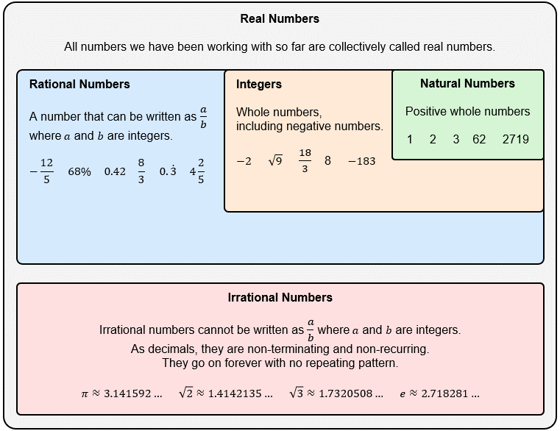

- Identify whether a number is rational or irrational
Using a calculator, represent these numbers as decimals and decide whether they are irrational or rational.
- $\frac{1}{3}$ Rational Irrational | - $\sqrt{4}$ Rational Irrational
- $3$ Rational Irrational | - $\sqrt{5}$ Rational Irrational
- $0.3$ Rational Irrational | - $\sqrt{5}+1$ Rational Irrational
- $0.\dot{3}$ Rational Irrational | - $\frac{\sqrt{2}}{2}$ Rational Irrational
- $\sqrt{3}$ Rational Irrational | - $2\sqrt{2}$ Rational Irrational
- $\sqrt{9}$ Rational Irrational | - $π$ Rational Irrational
- $0.25$ Rational Irrational | - $-\frac{22.5}{7}$ Rational Irrational
- $25\%$ Rational Irrational | - $3.\overline{14}$ Rational Irrational

- Key Ideas
- Rational numbers can be written as a fraction $\frac{a}{b}$, where $a$ and $b$ are ………………… and $b≠0$
- If a number can be written as a terminating or ……………… decimal, then it is rational.
- Irrational numbers cannot be written as a fraction with integers, when written as a decimal, they are non-…………………………… and non-……………………………

- Example Approximate irrational numbers
Approximate $\sqrt{2}$ to 2 decimal places.  $\sqrt{2}=1.414213562…$  $≈1.41$ | Approximate $e$ to 2 decimal places.  $e=2.718281828…$  $≈2.72$

- Guided Practice
Approximate these numbers to 2 decimal places.
- $\sqrt{3}$  1.73 | - $π$  3.14 | - $\sqrt{25}$  5.00
- $\sqrt{18}$  4.24 | - $\frac{1}{\sqrt{3}}$  0.58 | - $2\sqrt{2}$  2.83

- Example Locate the approximate location of irrational numbers
$\sqrt{2}≈1.41$  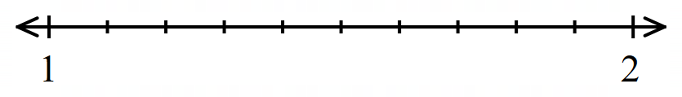 | $e≈2.72$  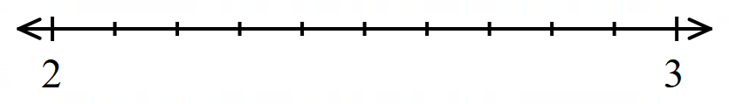

- Guided Practice
Using a calculator, locate the approximate location of these numbers on the number line.
- $\sqrt{3}$
- $-\sqrt{5}$
- $\frac{\sqrt{2}}{2}$
- $-π$

Foundation
- Circle which of these numbers are integers.
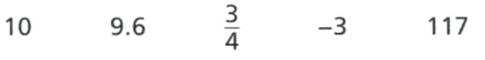
10, $-3$, 117
Explain why all integers are rational numbers.

Integers can be written with a denominator of 1.
- Circle which of these numbers are rational.
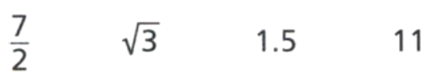

$$\frac{7}{2}, 1.5, 11$$
Explain how you know whether a number is rational.

The number can be written as a fraction with whole number numerator and denominator.
- Explain why $\sqrt{4}$ is a rational number.

$\sqrt{4}=2$, which is an integer, so it’s rational.
- Look at these numbers.

  - Which numbers are irrational?
$$\sqrt{3}, \sqrt{5}, 3\sqrt{7}, -\sqrt{3}$$
  - Which numbers are rational?
$$\sqrt{4}, 2\sqrt{100}, -\sqrt{25}$$

- Emily says:

0.7777... recurring is irrational as you cannot write it as a fraction.

Explain why she is incorrect.

0.777… can be written as $\frac{7}{9}$, so it’s rational.


- Dolly says:
$π$ is a rational number, since it is roughly equal to $\frac{22}{7}$

Explain why Dolly is incorrect.

$π$ is roughly equal to $\frac{22}{7}$ but not exactly. $π$ is a non-terminating, non-recurring decimal, so it is irrational.

- Becky says:
$\sqrt{25}$ is not rational, because it is a square root.

Explain why Becky is incorrect.

$\sqrt{25}$ simplifies to 5, which is rational.
- Using a calculator, approximate these numbers to 2 decimal places.
- $\sqrt{5}$  2.24 | - $2\sqrt{5}$  4.47 | - 1.61803399  1.62
- $\frac{22}{7}$  3.14 | - $\frac{π}{2}$  1.57 | - $e^{2}$  7.39

Development
- Complete the table.
Number | Rational/ Irrational? | Approximation  (2 d.p.) | Approximation  (3 d.p.) | Approximate location on number line
$$e$$ | Irrational | $$≈2.72$$ | $$≈2.718$$ | 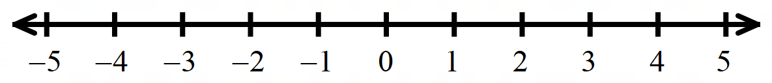
$$\sqrt{6}$$ | Irrational | 2.45 | 2.449
$$2\sqrt{6}$$ | Irrational | 4.90 | 4.899
$$\sqrt{24}$$ | Irrational | 4.90 | 4.899
$$\sqrt{13}$$ | Irrational | 3.61 | 3.606
$$\sqrt{16}$$ | Rational | 4.00 | 4.000
$$π$$ | Irrational | 3.14 | 3.142
$$3π$$ | Irrational | 9.42 | 9.425
$$0.\dot{3}$$ | Rational | 0.33 | 0.333
$$\frac{7}{3}$$ | Rational | 2.33 | 2.333
$$-5$$ | Rational | -5.00 | -5.000
$$-\sqrt{3}$$ | Irrational | -1.73 | -1.732

Surds

- Roots and Surds
- Square rooting $\sqrt{x}$ is the inverse operation of squaring $x^{2}$.
- We call a root a surd if it is irrational: E.g., $\sqrt{2}, \sqrt{3},\sqrt{5}, \sqrt[3]{7}$
- It is best to leave surds in exact form, rather than a rounded decimal.
- It is impossible (for now) to square root a negative number $\sqrt{-4}$, we say it is not real.

- Identify surds
Determine whether these roots are surds
- $\sqrt{3}$ | Surd Rational Not real
- $2\sqrt{3}$ | Surd Rational Not real
- $\sqrt{4}$ | Surd Rational Not real
- $\sqrt{8}$ | Surd Rational Not real
- $\sqrt{16}$ | Surd Rational Not real
- $2\sqrt{16}$ | Surd Rational Not real
- $3+\sqrt{16}$ | Surd Rational Not real
- $\sqrt[3]{16}$ | Surd Rational Not real
- $\sqrt[3]{8}$ | Surd Rational Not real
- $\sqrt[3]{6}$ | Surd Rational Not real
- $\sqrt{6}$ | Surd Rational Not real
- $\sqrt{9}$ | Surd Rational Not real
- $-\sqrt{9}$ | Surd Rational Not real
- $\sqrt[3]{9}$ | Surd Rational Not real
- $\sqrt{0}$ | Surd Rational Not real
- $\sqrt{-0}$ | Surd Rational Not real
- $\sqrt{-1}$ | Surd Rational Not real
- $-\sqrt{1}$ | Surd Rational Not real
- $-\sqrt{-1}$ | Surd Rational Not real
- $\sqrt[3]{-8}$ | Surd Rational Not real
- $\sqrt{-\left(-25\right)}$ | Surd Rational Not real

Foundation
- Tom says $\sqrt{1}$ is a surd
Katie says $\sqrt{2}$ is a surd
Who is correct?
A | Only Tom | B | Only Katie | C | Both | D | Neither

- Which of the following is not a surd?
A | $\sqrt{45}$ | B | $\sqrt{47}$ | C | $\sqrt{49}$ | D | $\sqrt{51}$

- Which of the following is not a surd?
A | $\sqrt{84}$ | B | $\sqrt{83}$ | C | $\sqrt{82}$ | D | $\sqrt{81}$

- Complete the sentences
  - A number that cannot be expressed as a fraction with integer numerator and denominator is called ……………………………………
  - A ………………… is an irrational root, for example $\sqrt{2}$ or $\sqrt[3]{5}$
  - The decimal representation of a surd is a decimal that goes on ……………………… and never ………………………………
  - $\sqrt{7}$ is a surd because its ………………… representation doesn’t repeat and goes on forever.
  - $\sqrt{25}$ is …………… a surd because its decimal representation is …………

- Jono says $\sqrt{18}$ is a surd. Explain why he is correct.

$\sqrt{18}$cannot be expressed as a fraction with integers. It is a non-terminating, non-recurring decimal.
- Becky says $\sqrt{25}$ is not a surd. Explain why she is correct.

$\sqrt{25}$ can be simplified to 5
- Circle the surds.

$$\sqrt{24}, \sqrt{2}, \sqrt{8},\sqrt{130}$$
- Express each number as a decimal using a calculator and then decide whether they are irrational or rational. Round the decimals to 2 d.p.
- $\sqrt{5}$  Irrational, 2.24 | - $18\%$  Rational, 0.18 | - $\frac{2}{5}$  Rational, 0.4 | - $-124\%$  Rational, $-1.24$
- $1\frac{5}{7}$  Rational, $1.\overline{714285}$ | - $-\sqrt{2}$  Irrational, $-1.41$ | - $2\sqrt{3}$  Irrational, 3.46 | - $π$  Irrational, 3.14
Show each number’s approximate location on the number line.

- Using a calculator, or otherwise, classify these numbers as either surds, rational, or not real.
- $\sqrt{7}$  surd | - $2\sqrt{11}$  surd | - $2\sqrt{25}$  rational | - $-5\sqrt{144}$  rational
- $\frac{3\sqrt{9}}{2}$  rational | - $\frac{-5\sqrt{3}}{2}$  surd | - $1-\sqrt{3}$  surd | - $2+\sqrt{4}$  rational
- $\sqrt{\frac{4}{25}}$  rational | - $\sqrt{\frac{5}{16}}$  surd | - $\sqrt{-11}$  Not real | - $\sqrt{99}$  surd

- Consider the number line:
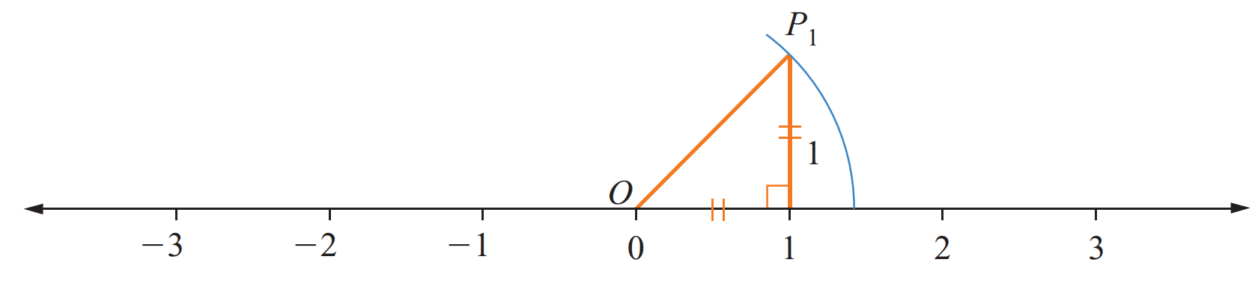

  - Use Pythagoras’ Theorem to calculate the length of ${OP}_{1}$

$$\sqrt{2}$$
  - Using a pair of compasses, with point at O, the location of $\sqrt{2}$ on the number line has been accurately marked. What is the approximate value of $\sqrt{2}$?

$$1.41$$
  - $\sqrt{2}$ can be placed on a number line. Is it a real number?
Yes

Surd Laws

- Language of Surds
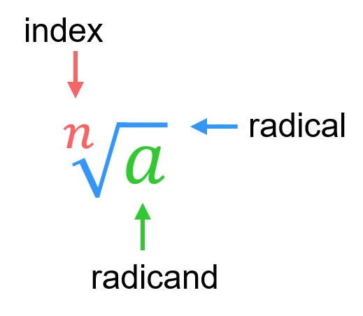

- Identify parts of a surd
Surd | Index | Radicand
$$\sqrt[3]{7}$$
$$\sqrt{7}$$
$$\sqrt[3]{a}$$
$$3\sqrt{a}$$
$$\sqrt[9]{n^{2}}$$
$$\sqrt[9]{n+5}$$
$$2\sqrt[6]{n^{2}+5}$$
 | $$5$$ | $$z^{3}$$

- Surd Laws
Inverse Relationship | Surd Law of Multiplication | Surd Law of Division
$${\left(\sqrt{x}\right)}^{2}=x \\ \sqrt{x^{2}}=x$$ | $$\sqrt{a}×\sqrt{b}=\sqrt{ab}$$ | $$\sqrt{a}÷\sqrt{b}=\sqrt{\frac{a}{b}}$$

- Multiply and Divide Surds using the Laws
${\left(\sqrt{11}\right)}^{2}$  $=11$ |  | $\sqrt{3}×\sqrt{10}$  $=\sqrt{30}$ |  | $\sqrt{24}÷\sqrt{8}$  $=\sqrt{3}$
Simplify these expressions.
- $\sqrt{3}×\sqrt{7}$  $$\sqrt{21}$$ | - $\sqrt{8}×\sqrt{2}$  $$4$$ |  | - $\sqrt{2}×\sqrt{11}$  $$\sqrt{22}$$ |  | - ${\left(\sqrt{12}\right)}^{2}$  $$12$$
- $\sqrt{20}÷\sqrt{2}$  $$\sqrt{10}$$ | - $\sqrt{45}÷\sqrt{5}$  $$3$$ |  | - $\sqrt{18}÷\sqrt{6}$  $$\sqrt{3}$$ |  | - $\sqrt{49}÷\sqrt{7}$  $$\sqrt{7}$$

- Identify whether you can use a surd law to simplify
- $\sqrt{7}×\sqrt{5}$  - $\sqrt{7}+\sqrt{5}$  - $\sqrt{7}÷\sqrt{5}$  - $\sqrt{7}-\sqrt{7}$ | Yes | No  Yes | No  Yes | No  Yes | No | - $\sqrt{6}×\sqrt{0.5}$  - $\sqrt{6}÷\sqrt{10}$  - $\sqrt{6}+\sqrt{12}$  - $\sqrt{6}-\sqrt{3}$ | Yes | No  Yes | No  Yes | No  Yes | No

- Key Ideas
- Raising to a power and rooting are ……………… operations; they undo each other.
- $\sqrt{x^{2}}={\left(\sqrt{x}\right)}^{2}=$ ………
- The surd law of multiplication says that $\sqrt{a}×\sqrt{b}=$ …………
- The surd law of division says that $\frac{\sqrt{a}}{\sqrt{b}}$ $=$ …………

Foundation
- Evaluate the following.
- ${\left(\sqrt{11}\right)}^{2}$  11 | - $\sqrt{{11}^{2}}$  11 | - ${\left(\sqrt{8}\right)}^{2}$  8 | - $\sqrt{8^{2}}$  8 | - ${\left(\sqrt{6}\right)}^{2}$  6

  - Write down the value of
i $\sqrt{4}$  2 | ii $\sqrt{25}$  5 | iii $\sqrt{100}$  10 | ii $\sqrt{400}$  20

  - Hence show that
i $\sqrt{4}×\sqrt{100}=\sqrt{400}$  $$2×10=20$$ | ii $\sqrt{100}÷\sqrt{4}=\sqrt{25}$  $$10÷2=5$$

  - Write down the value of
i $\sqrt{9}$  3 | ii $\sqrt{16}$  4

  - Hence show that
i $\sqrt{9}+\sqrt{16}≠\sqrt{25}$  $$3+4≠5$$ | ii $\sqrt{16}-\sqrt{9}≠\sqrt{7}$  $$4-3≠\sqrt{7}$$

- Use the fact that $\sqrt{a}×\sqrt{b}=\sqrt{ab}$ to write each expression as a single surd.
- $\sqrt{5}×\sqrt{3}$  $$\sqrt{15}$$ | - $\sqrt{7}×\sqrt{11}$  $$\sqrt{77}$$ | - $\sqrt{51}×\sqrt{2}$  $$\sqrt{102}$$ | - $\sqrt{15}×\sqrt{21}$  $$\sqrt{315}$$
- $\sqrt{2}×\sqrt{11}$  $$\sqrt{22}$$ | - $\sqrt{3}×\sqrt{7}$  $$\sqrt{21}$$ | - $\sqrt{10}×\sqrt{3}$  $$\sqrt{30}$$ | - $\sqrt{10}×\sqrt{7}$  $$\sqrt{70}$$

- Use the fact that $\sqrt{a}÷\sqrt{b}=\sqrt{\frac{a}{b}}$ to write each expression as a single surd.
- $\sqrt{21}÷\sqrt{3}$  $$\sqrt{7}$$ | - $\sqrt{26}÷\sqrt{2}$  $$\sqrt{13}$$ | - $\sqrt{51}÷\sqrt{17}$  $$\sqrt{3}$$ | - $\sqrt{3}÷\sqrt{21}$  $$\sqrt{\frac{1}{7}}$$
- $\frac{\sqrt{20}}{\sqrt{2}}$  $$\sqrt{10}$$ | - $\frac{\sqrt{45}}{\sqrt{5}}$  $$3$$ | - $\frac{\sqrt{32}}{\sqrt{8}}$  2 | - $\frac{\sqrt{35}}{\sqrt{5}}$  $$\sqrt{7}$$

Development

  - Using your knowledge of index laws, explain why ${\left(3\sqrt{5}\right)}^{2}=3^{2}{\left(\sqrt{5}\right)}^{2}$
Index law of power of a product: ${\left(ab\right)}^{n}=a^{n}b^{n}$
  - Therefore, explain why ${\left(3\sqrt{5}\right)}^{2}=45$
$$3^{2}{\sqrt{5}}^{2}=9\left(5\right)=45$$

- Evaluate the following.
- ${\left(3\sqrt{2}\right)}^{2}$  18 | - ${\left(2\sqrt{3}\right)}^{2}$  12 | - ${\left(5\sqrt{2}\right)}^{2}$  50 | - ${\left(10\sqrt{7}\right)}^{2}$  700 | - ${\left(4\sqrt{5}\right)}^{2}$  80

- Simplify these expressions. Write your answer as a whole number.
- ${\left(\sqrt{2}\right)}^{2}$  2 | - ${\left(\sqrt{10}\right)}^{2}$  10 | - $3{\left(\sqrt{10}\right)}^{2}$  30
- ${\left(\sqrt{3}\right)}^{2}$  3 | - ${\left(2\sqrt{10}\right)}^{2}$  40 | - $5{\left(\sqrt{10}\right)}^{2}$  50
- ${\left(\sqrt{5}\right)}^{2}$  5 | - ${\left(3\sqrt{10}\right)}^{2}$  90 | - ${10\left(\sqrt{10}\right)}^{2}$  100

Simplifying Surds

- Simplify surds
- Factorise the radicand (number inside the root) according to its highest square factor.
$$4, 9 , 16, 25, 36, 49, 64, 81, 100, 121, 144…$$
- Split the surd, then simplify perfect squares.

- Example Simplify surds
$\sqrt{45}$  1. $\sqrt{9×5}$  2. $\sqrt{9}×\sqrt{5}$  $=3\sqrt{5}$ | $3\sqrt{40}$  1. $3\sqrt{4×10}$  2. $3\sqrt{4}\sqrt{10}$  $=6\sqrt{10}$ | $$\frac{\sqrt{80}}{3}$$  1. $\frac{\sqrt{16×5}}{3}$  2. $\frac{4\sqrt{5}}{3}$

- Guided Practice
Simplify these surds.
- $\sqrt{12}$  $$2\sqrt{3}$$ | - $\sqrt{28}$  $$2\sqrt{7}$$ | - $\sqrt{54}$  $$3\sqrt{6}$$ | - $3\sqrt{8}$  $$6\sqrt{2}$$
- $\frac{\sqrt{48}}{2}$  $$2\sqrt{3}$$ | - $\frac{5\sqrt{40}}{6}$  $$\frac{5\sqrt{10}}{3}$$ | - $\sqrt{\frac{75}{9}}$  $$\frac{5}{\sqrt{3}} or\frac{5\sqrt{3}}{3}$$ | - $\sqrt{\frac{50}{16}}$  $$\frac{5}{2\sqrt{2}} or \frac{5\sqrt{2}}{4}$$

Foundation
- Simplify these surds
- $\sqrt{12}$  $$=\sqrt{4×3 }$$  $=$  $$2\sqrt{3}$$ | - $\sqrt{45}$  $$3\sqrt{5}$$ | - $\sqrt{24}$  $$2\sqrt{6}$$ | - $\sqrt{48}$  $$4\sqrt{3}$$
- $\sqrt{75}$  $$5\sqrt{3}$$ | - $\sqrt{500}$  $$10\sqrt{5}$$ | - $\sqrt{98}$  $$7\sqrt{2}$$ | - $\sqrt{90}$  $$3\sqrt{10}$$
- $\sqrt{128}$  $$8\sqrt{2}$$ | - $\sqrt{360}$  $$6\sqrt{10}$$ | - $\sqrt{162}$  $$9\sqrt{2}$$ | - $\sqrt{80}$  $$4\sqrt{5}$$

- There are many ways to factorise $\sqrt{600}$. 1 is given below. Find 2 more different ways.
$\sqrt{600}=2\sqrt{150}$

$$5\sqrt{24}, 10\sqrt{6}$$
What is the simplest form of $\sqrt{600}$?
$$10\sqrt{6}$$

- Work out each value of $x$
- $\sqrt{150}=5\sqrt{x}$  6 | - $\sqrt{300}=x\sqrt{3}$  10 | - $\sqrt{x}=7\sqrt{13}$  637

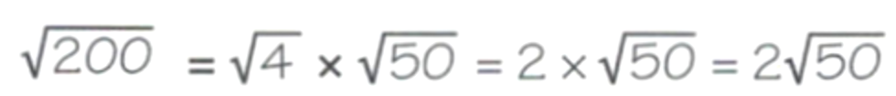
- Samira has simplified $\sqrt{200}$:
Explain how Samira can improve her answer.

Further simplify $\sqrt{50}$; $2\sqrt{50}=2×5\sqrt{2}=10\sqrt{2}$

Development
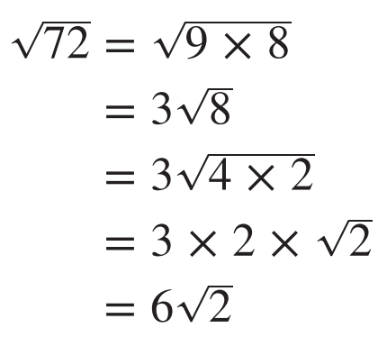
- Consider the working out to simplify $\sqrt{72}$

  - Explain why the working out for simplifying $\sqrt{72}$ is longer than it needs to be.

You can split $\sqrt{72}$ to $\sqrt{36}\sqrt{2}$;
9 was not the largest square factor of 72.
  - Therefore, simplify $\sqrt{72}$ using as few steps as possible.

$$\sqrt{72}=\sqrt{36}\sqrt{2}=6\sqrt{2}$$
- Simplify these surds. Try to write as little working out as possible.
- $\sqrt{8}$  $$2\sqrt{2}$$ | - $\sqrt{192}$  $$8\sqrt{3}$$ | - $\sqrt{160}$  $$4\sqrt{10}$$
- $\sqrt{12}$  $$2\sqrt{3}$$ | - $\sqrt{320}$  $$8\sqrt{5}$$ | - $\sqrt{1600}$  $$40$$
- $\sqrt{32}$  $$4\sqrt{2}$$ | - $\sqrt{80}$  $$4\sqrt{5}$$ | - $\sqrt{200}$  $$10\sqrt{2}$$
- $\sqrt{64}$  $$8$$ | - $\sqrt{40}$  $$2\sqrt{10}$$ | - $\sqrt{250}$  $$5\sqrt{10}$$
- $\sqrt{128}$  $$8\sqrt{2}$$ | - $\sqrt{90}$  $$3\sqrt{10}$$ | - $\sqrt{175}$  $$5\sqrt{7}$$

- Simplify these surds.
- $2\sqrt{18}$  $=$ $2×3\sqrt{2}$  $=$ $6\sqrt{2}$ | - $4\sqrt{48}$  $=4×4\sqrt{3}$  $$16\sqrt{3}$$ | - $3\sqrt{98}$  $$21\sqrt{2}$$ | - $4\sqrt{125}$  $$20\sqrt{5}$$

- Simplify these surds.
- $\sqrt{8}$  $$2\sqrt{2}$$ | - $\sqrt{72}$  $$6\sqrt{2}$$ | - $5\sqrt{720}$  $$60\sqrt{5}$$
- $2\sqrt{8}$  $$4\sqrt{2}$$ | - $5\sqrt{72}$  $$30\sqrt{2}$$ | - $5\sqrt{360}$  $$30\sqrt{10}$$
- $3\sqrt{8}$  $$6\sqrt{2}$$ | - $5\sqrt{144}$  $$60$$ | - $5\sqrt{36}$  $$30$$
- $\sqrt{72}$  $$6\sqrt{2}$$ | - $5\sqrt{1440}$  $$60\sqrt{10}$$ | - $5\sqrt{25}$  25

- Determine the exact side length, in simplest form, of a square with the given area.
- 32 m²  $4\sqrt{2}$ m | - 120 cm²  $2\sqrt{30}$ cm | - 240 mm²  $4\sqrt{15}$ mm

- Determine the exact radius, in simplest form, of a circle with the given area. $A=πr^{2}$
- 24$π$ m²  $2\sqrt{6}$ m | - 54$π$ cm²  $3\sqrt{6}$ cm | - 128$π$ mm²  $8\sqrt{2}$ mm

- Simplify.
- $\sqrt{675}$  $$15\sqrt{3}$$ | - $\sqrt{1183}$  $$13\sqrt{7}$$ | - $\sqrt{2883}$  $$31\sqrt{3}$$  Sorry :)

Mastery
- Express these surds as a square root of a positive integer.
- $2\sqrt{3}$  $$=\sqrt{4}×\sqrt{3}$$  $$=\sqrt{12}$$ | - $4\sqrt{2}$  $=\sqrt{16}×\sqrt{2}$  $=$ …………  $$\sqrt{32}$$ | - $3\sqrt{3}$  $$\sqrt{27}$$ | - $3\sqrt{5}$  $$\sqrt{45}$$
- $6\sqrt{3}$  $$\sqrt{108}$$ | - $8\sqrt{2}$  $$\sqrt{128}$$ | - $10\sqrt{7}$  $$\sqrt{700}$$ | - $9\sqrt{10}$  $$\sqrt{810}$$

- Use Pythagoras’ Theorem to find the unknown length in simplest form.
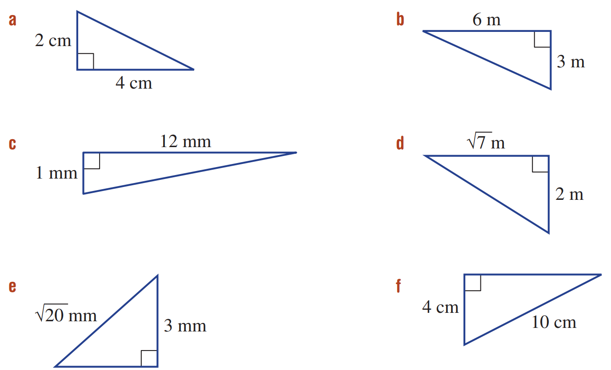  $2\sqrt{5}$ cm | $3\sqrt{5}$ m | $\sqrt{11}$ m
$\sqrt{145}$ mm | $\sqrt{11}$ mm | $2\sqrt{21}$ cm

- Simplify the following.
- $\sqrt[3]{125}-\sqrt[3]{8}$  $$3$$ | - $\sqrt[3]{24}$  $$2 \sqrt[3]{3}$$ | - $\sqrt[3]{2000}$  $$10 \sqrt[3]{2}$$ | - $\sqrt[5]{64}$  $$2 \sqrt[5]{2}$$

- Simplify the following.
- $\sqrt{a^{2}b}$  $$a\sqrt{b}$$ | - $\sqrt{a^{4}b^{2}}$  $$a^{2}b$$ | - $\sqrt[3]{a^{6}b^{3}}$  $$a^{2}b$$ | - $\sqrt{a^{5}b^{3}}$  $$a^{2}b\sqrt{ab}$$

Addition and Subtraction of Surds

- Addition and Subtraction of Surds
We can only add and subtract “like” surds; like surds have the same radicand and index.
- Simplify all surds.
- Collect like surds.

- Example Add and subtract surds
$3\sqrt{7}-\sqrt{6}+2\sqrt{7}$  2. $3\sqrt{7}-\sqrt{6}+2\sqrt{7}$  ¯¯¯  ¯¯¯  $=5\sqrt{7}-\sqrt{6}$ | $\sqrt{44}+\sqrt{99}$  1. $\sqrt{4}\sqrt{11}+\sqrt{9}\sqrt{11}$  $2\sqrt{11}+3\sqrt{11}$  2. $5\sqrt{11}$

- Guided Practice
Simplify these expressions.
- $2\sqrt{11}+6\sqrt{11}$  $$8\sqrt{11}$$ | - $3\sqrt{6}+\sqrt{6}$  $$4\sqrt{6}$$ | - $5\sqrt{7}+3\sqrt{5}-4\sqrt{7}$  $$\sqrt{7}+3\sqrt{5}$$
- $\sqrt{8}+\sqrt{2}$  $$3\sqrt{2}$$ | - $\sqrt{12}-\sqrt{3}$  $$\sqrt{3}$$ | - $\sqrt{54}+\sqrt{24}$  $$5\sqrt{6}$$
- $2\sqrt{8}-\sqrt{18}$  $$\sqrt{2}$$ | - $2\sqrt{5}+\sqrt{45}$  $$5\sqrt{5}$$ | - $\sqrt{72}-\sqrt{50}+\sqrt{12}$  $$2\sqrt{3}+\sqrt{2}$$

- Key Ideas
- We can only add or subtract …………… surds; surds with the same ……………… and ………………….
- Sometimes we can create like surds by ……………… them.

Foundation
- Decide whether these pairs of numbers are like or unlike surds.
- $3\sqrt{4}$, $4\sqrt{2}$  unlike | - $5\sqrt{3}$, $2\sqrt{3}$  like | - $4\sqrt{2}$, $4\sqrt{7}$  unlike | - $\sqrt{3}$, $3\sqrt{5}$  unlike
- $6\sqrt{6}$, $3\sqrt{3}$  unlike | - $\sqrt{8}$, $-\sqrt{8}$  like | - $19\sqrt{2}$, $-2\sqrt{2}$  like | - $-3\sqrt{6}$, $3\sqrt{5}$  unlike

- Complete the following:
  - $11x-5x=$ …………, so $11\sqrt{2}-5\sqrt{2}=$ …………
$$6x, 6\sqrt{2}$$
  - $8x-x=$ …………, so $8\sqrt{2}-\sqrt{2}=$ …………
$$7x, 7\sqrt{2}$$
  - $8x-7x=$ …………, so $8\sqrt{2}-7\sqrt{2}=$ …………
$$x, \sqrt{2}$$

- Simplify these expressions.
- $2\sqrt{5}+4\sqrt{5}$  $$6\sqrt{5}$$ | - $5\sqrt{3}-2\sqrt{3}$  $$3\sqrt{3}$$ | - $7\sqrt{2}-3\sqrt{2}$  $$4\sqrt{2}$$
- $8\sqrt{2}-5\sqrt{2}$  $$3\sqrt{2}$$ | - $4\sqrt{10}+3\sqrt{10}-\sqrt{10}$  $$6\sqrt{10}$$ | - $\sqrt{21}-5\sqrt{21}+2\sqrt{21}$  $$-2\sqrt{21}$$

- Simplify the surd $\sqrt{48}$ ………………………
$$4\sqrt{3}$$
Hence, simplify the following:
- $\sqrt{3}+\sqrt{48}$  $$5\sqrt{3}$$ | - $\sqrt{48}-7\sqrt{3}$  $$-3\sqrt{3}$$ | - $5\sqrt{48}-3\sqrt{3}$  $$17\sqrt{3}$$

- Simplify all surds, then collect like surds.
- $\sqrt{8}-\sqrt{2}$  $=2\sqrt{2}-\sqrt{2}$  $=$ ……………  $$\sqrt{2}$$ | - $\sqrt{8}+3\sqrt{2}$  $$5\sqrt{2}$$ | - $\sqrt{27}+\sqrt{3}$  $$4\sqrt{3}$$
- $\sqrt{20}-\sqrt{5}$  $$\sqrt{5}$$ | - $4\sqrt{18}-5\sqrt{2}$  $$7\sqrt{2}$$ | - $2\sqrt{75}+2\sqrt{3}$  $$12\sqrt{3}$$
- $3\sqrt{44}+2\sqrt{11}$  $$8\sqrt{11}$$ | - $3\sqrt{8}-\sqrt{18}$  $$3\sqrt{2}$$ | - $2\sqrt{125}-3\sqrt{45}$  $$\sqrt{5}$$

Development
- Simplify these expressions.
- $2\sqrt{3}+3\sqrt{2}-\sqrt{3}+2\sqrt{3}$  $$3\sqrt{3}+3\sqrt{2}$$ | - $3\sqrt{5}-4\sqrt{2}+\sqrt{5}-3\sqrt{2}$  $$4\sqrt{5}-7\sqrt{2}$$ | - $5\sqrt{2}+2\sqrt{5}-7\sqrt{2}-\sqrt{5}$  $$-2\sqrt{2}+\sqrt{5}$$
- $2\sqrt{3}+2\sqrt{7}+2\sqrt{3}-2\sqrt{7}$  $$4\sqrt{3}$$ | - $5\sqrt{11}+3\sqrt{6}-3\sqrt{11}$  $$2\sqrt{11}+3\sqrt{6}$$ | - $-4\sqrt{10}-5\sqrt{2}+\sqrt{10}$  $$-3\sqrt{10}-5\sqrt{2}$$

- Simplify these expressions.
- $2\sqrt{3}+5\sqrt{3}$  7$\sqrt{3}$ | - $2\sqrt{3}+6\sqrt{27}$  $$20\sqrt{3}$$ | - $6\sqrt{60}+2\sqrt{240}$  20$\sqrt{15}$
- $2\sqrt{3}+5\sqrt{6}$  Can’t simplify | - $2\sqrt{30}+6\sqrt{27}$  2$\sqrt{30}+18\sqrt{3}$ | - $6\sqrt{6}+2\sqrt{24}$  $$10\sqrt{6}$$
- $2\sqrt{3}+5\sqrt{12}$  $$12\sqrt{3}$$ | - $2\sqrt{30}+6\sqrt{120}$  $$14\sqrt{30}$$ | - $6\sqrt{6}+2\sqrt{24}+5\sqrt{36}$  $$10\sqrt{6}+30$$
- $2\sqrt{3}+5\sqrt{27}$  $$17\sqrt{3}$$ | - $6\sqrt{30}+2\sqrt{120}$  $$10\sqrt{30}$$ | - $6\sqrt{16}+2\sqrt{24}+5\sqrt{36}$  $$54+4\sqrt{6}$$

- Calculate the perimeter in simplest form.
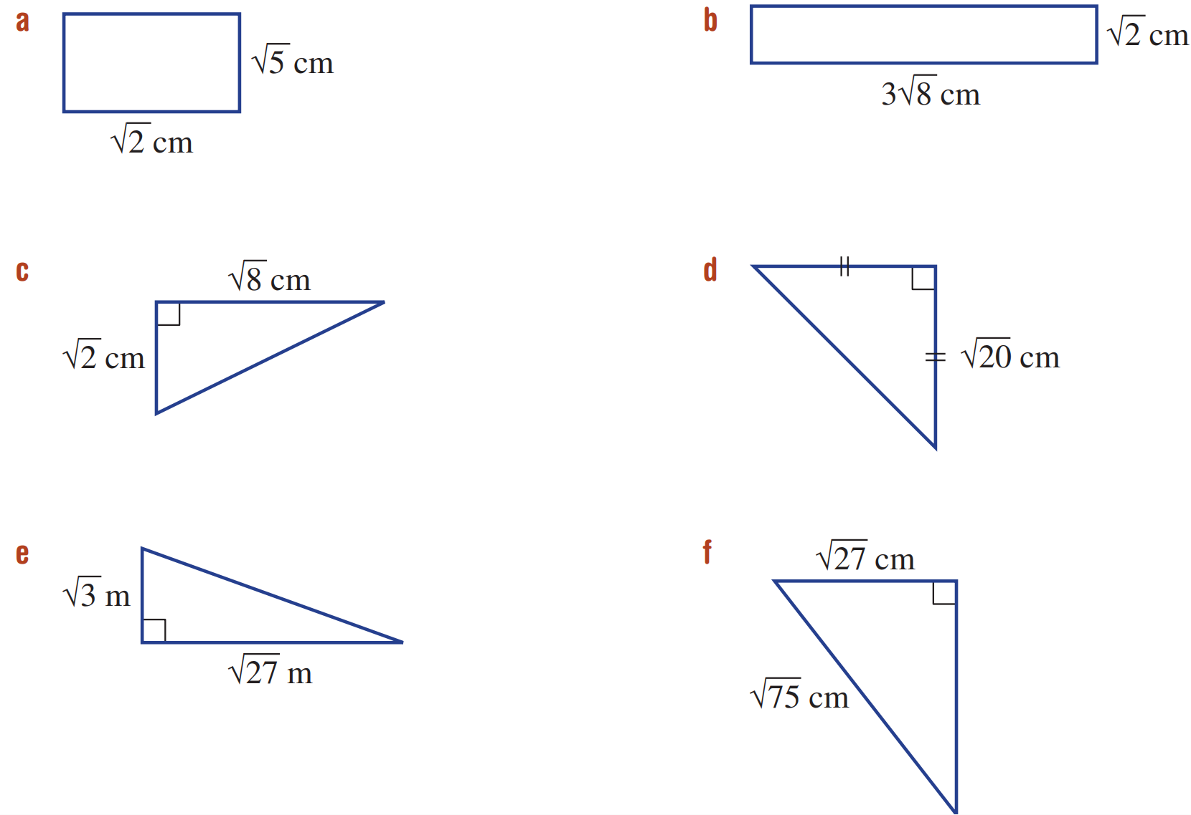  2$\sqrt{2}+2\sqrt{5}$ | $$14\sqrt{2}$$ | $$3\sqrt{2}+\sqrt{10}$$
$$4\sqrt{5}+2\sqrt{10}$$ | $$4\sqrt{3}+\sqrt{30}$$ | $$12\sqrt{3}$$

Mastery
- Prove that each of the following simplifies to zero by showing all steps.
- $5\sqrt{3}-\sqrt{108}+\sqrt{3}$ | - $6\sqrt{2}-2\sqrt{32}+2\sqrt{2}$
- $2\sqrt{20}-7\sqrt{5}+\sqrt{45}$ | - $3\sqrt{2}-2\sqrt{27}-\sqrt{50}+6\sqrt{3}+\sqrt{8}$

- Simplify the surds and combine the fractions using a common denominator.
- $\frac{\sqrt{8}}{3}$ $-$ $\frac{\sqrt{2}}{5}$  $$\frac{7\sqrt{2}}{15}$$ | - $\frac{\sqrt{12}}{4}$ $+$ $\frac{\sqrt{3}}{6}$  $$\frac{2\sqrt{3}}{3}$$ | - $\frac{3\sqrt{5}}{4}$ $-$ $\frac{\sqrt{20}}{3}$  $$\frac{\sqrt{5}}{12}$$
- $\frac{\sqrt{98}}{4}$ $-$ $\frac{5\sqrt{2}}{2}$  $$-\frac{3\sqrt{2}}{4}$$ | - $\frac{2\sqrt{75}}{5}$ $-$ $\frac{3\sqrt{3}}{2}$  $$\frac{\sqrt{3}}{2}$$ | - $\frac{\sqrt{63}}{9}$ $-$ $\frac{4\sqrt{7}}{5}$  $$\frac{-21\sqrt{7}}{45}$$
- $\frac{2\sqrt{18}}{3}$ $-$ $\frac{\sqrt{72}}{2}$  $$-\sqrt{2}$$ | - $\frac{\sqrt{54}}{4}$ $+$ $\frac{\sqrt{24}}{7}$  $$\frac{29\sqrt{6}}{28}$$ | - $\frac{\sqrt{27}}{5}$ $-$ $\frac{\sqrt{108}}{10}$  0
- $\frac{5\sqrt{48}}{6}$ $+$ $\frac{2\sqrt{147}}{3}$  $$8\sqrt{3}$$ | - $\frac{2\sqrt{96}}{5}$ $-$ $\frac{\sqrt{600}}{7}$  $$\frac{34\sqrt{6}}{35}$$ | - $\frac{3\sqrt{125}}{14}$ $-$ $\frac{2\sqrt{80}}{21}$  $$\frac{29\sqrt{5}}{42}$$
- Simplify fully.
- $\sqrt{600}+\sqrt{300}-\sqrt{216}$  $$4\sqrt{6}+10\sqrt{3}$$ | - $4\sqrt{18}+3\sqrt{12}-2\sqrt{50}$  $$2\sqrt{2}+6\sqrt{3}$$ | - $2\sqrt{175}-5\sqrt{140}-3\sqrt{28}$  4$\sqrt{7}-10\sqrt{35}$

- Find the value of $x$.
- $\sqrt{63}-\sqrt{28}=\sqrt{x}$  7 | - $\sqrt{80}-\sqrt{20}=\sqrt{x}$  20 | - $2\sqrt{150}-3\sqrt{24}=\sqrt{x}$  96

Multiplying Surds

- Multiplying Surds
$$a\sqrt{x}×b\sqrt{y}=ab\sqrt{xy}$$
- Multiply the coefficients and the radicands separately.
- Simplify, if possible.

- Example Multiply surds
$\sqrt{15}×\sqrt{5}$  1. $\sqrt{75}$  2. $5\sqrt{3}$ | $5\sqrt{6}×7\sqrt{10}$  1. $35\sqrt{60}$  2. $70\sqrt{15}$

- Guided Practice
Simplify these expressions.
- $\sqrt{7}×\sqrt{3}$  $$\sqrt{21}$$ | - $\sqrt{5}×\sqrt{20}$  $$10$$ | - $\sqrt{12}×\sqrt{8}$  $$4\sqrt{6}$$
- $2×3\sqrt{2}$  $$6\sqrt{2}$$ | - $2\sqrt{6}×5\sqrt{3}$  $$30\sqrt{2}$$ | - $-4\sqrt{5}×3\sqrt{11}$  $$-12\sqrt{55}$$
- $2\sqrt{3}×3\sqrt{15}$  $$18\sqrt{5}$$ | - ${\left(2\sqrt{5}\right)}^{2}$  $$20$$ | - $3\sqrt{2}×-4\sqrt{6}$  $$-24\sqrt{3}$$

- Key Ideas
- $x\sqrt{m}×y\sqrt{n}=$ ……………………
- Remember to …………… the result as much as possible.

Foundation
- Simplify these expressions.
- $\sqrt{3}×\sqrt{5}$  $$\sqrt{15}$$ | - $\sqrt{7}×\sqrt{3}$  $$\sqrt{21}$$ | - $\sqrt{2}×\sqrt{13}$  $$\sqrt{26}$$
- $\sqrt{2}×(-\sqrt{15})$  $$-\sqrt{30}$$ | - $-\sqrt{6}×\sqrt{5}$  $$-\sqrt{30}$$ | - $-\sqrt{6}×(-\sqrt{11})$  $$\sqrt{66}$$
- $\sqrt{20}÷\sqrt{2}$  $$\sqrt{10}$$ | - $\sqrt{18}÷\sqrt{3}$  $$\sqrt{6}$$ | - $\sqrt{30}÷(-\sqrt{6})$  $$-\sqrt{5}$$
- $\frac{\sqrt{15}}{\sqrt{5}}$  $$\sqrt{3}$$ | - $\frac{\sqrt{30}}{\sqrt{3}}$  $$\sqrt{10}$$ | - $-\frac{\sqrt{26}}{\sqrt{2}}$  $$-\sqrt{13}$$

- Simplify the following. Ensure your final answer is fully simplified.
- $\sqrt{9}×\sqrt{9}$  9 | - $\sqrt{14}×\sqrt{7}$  $$7\sqrt{2}$$ | - $\sqrt{2}×\sqrt{22}$  $$2\sqrt{11}$$
- $\sqrt{3}×\sqrt{18}$  $$3\sqrt{6}$$ | - $\sqrt{10}×\sqrt{5}$  $$5\sqrt{2}$$ | - $\sqrt{12}×\sqrt{8}$  $$4\sqrt{6}$$
- ${\left(2\sqrt{3}\right)}^{2}$  12 | - ${\left(7\sqrt{3}\right)}^{2}$  147 | - ${\left(9\sqrt{2}\right)}^{2}$  162

- Simplify $\sqrt{8}×\sqrt{27}$ by:
- Simplifying each surd then multiplying  $$2\sqrt{2}×3\sqrt{3}$$  $$=6\sqrt{6}$$ | - Multiplying the surds then simplifying.  $$\sqrt{216}$$  $$=\sqrt{36}\sqrt{6}$$  $$=6\sqrt{6}$$
Why is simplifying before multiplying easier in the example above?

You don’t need to find square factors of a large number.
Simplify these expressions by simplifying each surd before multiplying.
- $\sqrt{8}×\sqrt{18}$  $=2\sqrt{}×3\sqrt{}$  $=$  12 | - $\sqrt{54}×\sqrt{8}$  $$12\sqrt{3}$$ | - $\sqrt{75}×\sqrt{3}$  15 | - $\sqrt{12}×\sqrt{18}$  $$6\sqrt{6}$$

Development
- Simplify these expressions.
- $\sqrt{2}×\sqrt{3}$  $$\sqrt{6}$$ | - $\sqrt{12}×\sqrt{3}$  6 | - $\sqrt{20}×\sqrt{4}$  $$4\sqrt{5}$$
- $\sqrt{4}×\sqrt{3}$  $$2\sqrt{3}$$ | - $\sqrt{12}×\sqrt{4}$  $$4\sqrt{3}$$ | - $\sqrt{20}×\sqrt{5}$  $$10$$
- $\sqrt{5}×\sqrt{3}$  $$\sqrt{15}$$ | - $\sqrt{11}×\sqrt{4}$  $$2\sqrt{11}$$ | - $\sqrt{20}×\sqrt{10}$  $$10\sqrt{2}$$
- $\sqrt{6}×\sqrt{3}$  $$3\sqrt{2}$$ | - $\sqrt{10}×\sqrt{4}$  $$2\sqrt{10}$$ | - $\sqrt{20}×\sqrt{20}$  20
- $\sqrt{24}×\sqrt{3}$  $$6\sqrt{2}$$ | - $\sqrt{10}×\sqrt{8}$  $$4\sqrt{5}$$ | - $\sqrt{20}×\sqrt{40}$  $$20\sqrt{2}$$

- Simplify these expressions.
- $2\sqrt{2}×\sqrt{3}$  $$2\sqrt{6}$$ | - $2\sqrt{12}×3\sqrt{3}$  $$36$$ | - $\sqrt{20}×2\sqrt{4}$  $$8\sqrt{5}$$
- $2\sqrt{4}×\sqrt{3}$  $$4\sqrt{3}$$ | - $2\sqrt{12}×3\sqrt{4}$  $$24\sqrt{3}$$ | - $5\sqrt{20}×3\sqrt{5}$  $$150$$
- $\sqrt{5}×2\sqrt{3}$  $$2\sqrt{15}$$ | - $2\sqrt{11}×3\sqrt{4}$  $$12\sqrt{11}$$ | - $5\sqrt{20}×3\sqrt{10}$  $$150\sqrt{2}$$
- $\sqrt{6}×2\sqrt{3}$  $$6\sqrt{2}$$ | - $\sqrt{10}×2\sqrt{4}$  $$4\sqrt{10}$$ | - $5\sqrt{20}×3\sqrt{20}$  $$300$$
- $\sqrt{24}×3\sqrt{3}$  $$18\sqrt{2}$$ | - $\sqrt{10}×2\sqrt{8}$  $$8\sqrt{5}$$ | - $2\sqrt{20}×3\sqrt{40}$  $$120\sqrt{2}$$

Mastery
- Consider the method of factorising a surd before multiplying:
- Example Factorise a surd before multiplying
$$\sqrt{7}×\sqrt{14}$$  $=\sqrt{7}×\sqrt{2}\sqrt{7}$  $=7\sqrt{2}$ | The “normal” method would have been to multiply $7$ and 14, then find the largest square factor. Why is this method faster?  This method avoids working with large numbers.

Use the method of factorising to simply these surd multiplications.
- $\sqrt{8}×\sqrt{24}$  $=\sqrt{8}×\sqrt{}\sqrt{8}$  $=$  $8\sqrt{3}$ | - $\sqrt{12}×\sqrt{18}$  $=\sqrt{}\sqrt{6}×\sqrt{}\sqrt{6}$  $=$  $$6\sqrt{6}$$ | - $2\sqrt{14}×\sqrt{21}$  $$14\sqrt{6}$$ | - $\sqrt{11}×\sqrt{55}$  $$11\sqrt{5}$$

- Simplify the following. Ensure your final answer is fully simplified.
For some questions, it is useful to simplify before multiplying or factorise the surd.
- $2\sqrt{5}×\sqrt{15}$  $$10\sqrt{3}$$ | - $3\sqrt{7}×\sqrt{14}$  $$21\sqrt{2}$$ | - $-5\sqrt{10}×\sqrt{30}$  $$-50\sqrt{3}$$
- $3\sqrt{6}×(-\sqrt{18})$  $$-18\sqrt{3}$$ | - $3\sqrt{14}×2\sqrt{21}$  $$42\sqrt{6}$$ | - $-2\sqrt{7}×(-3\sqrt{14})$  $$42\sqrt{2}$$
- $\sqrt{24}×\sqrt{20}$  $$4\sqrt{30}$$ | - $\sqrt{54}×\sqrt{75}$  $$45\sqrt{2}$$ | - $2\sqrt{72}×3\sqrt{80}$  $$144\sqrt{10}$$
- $\sqrt{108}×\left(-2\sqrt{125}\right)$  $$-60\sqrt{15}$$ | - $-4\sqrt{27}×(-\sqrt{28})$  $24\sqrt{21}$ | - $\sqrt{98}×\sqrt{300}$  $$70\sqrt{6}$$
- Determine the unknown side of the following right-angled triangles.
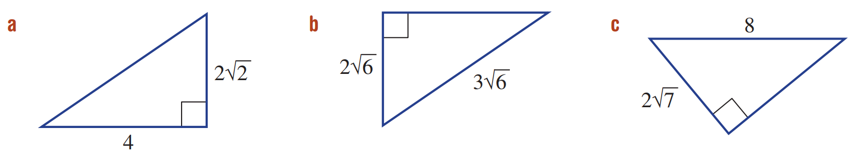  $$2\sqrt{6}$$ | $$\sqrt{30}$$ | $$6$$

- Find the length of the diagonal of a square, which has an area of 12 cm².
A square is a rhombus. The diagonals are equal.
$$A=\frac{xy}{2}$$
$$12=\frac{x^{2}}{2}$$
$$x^{2}=24$$
$$x=2\sqrt{6}$$

Alternate method, each side of the square is $\sqrt{12}$
Using Pythaogras, diagonal is $\sqrt{{\left(\sqrt{12}\right)}^{2}+{\left(\sqrt{12}\right)}^{2}}$
$$=\sqrt{12+12}$$
$$=\sqrt{24}$$
$$=2\sqrt{6}$$

Dividing Surds

- Dividing Surds
$$a\sqrt{x}÷b\sqrt{y}=\frac{a}{b}\sqrt{\frac{x}{y}}$$

- Divide the coefficients and the radicands separately.
- Simplify, if possible.

- Example Divide surds
$\sqrt{10}÷\sqrt{15}$  1. $\sqrt{\frac{10}{15}}$  2. $=$ $\sqrt{\frac{2}{3}}$  $=$ $\frac{\sqrt{2}}{\sqrt{3}}$ | $18\sqrt{48}÷6\sqrt{2}$  1. $\frac{18}{6}\sqrt{\frac{48}{2}}$  2. $=3\sqrt{24}$  $=3\sqrt{4}\sqrt{6}$  $=6\sqrt{6}$

- Guided Practice
Simplify:
- $\sqrt{15}÷\sqrt{3}$  $$\sqrt{5}$$ | - $3\sqrt{10}÷\sqrt{5}$  $$3\sqrt{2}$$ | - $6\sqrt{21}÷3\sqrt{7}$  $$2\sqrt{3}$$
- $8\sqrt{11}÷6\sqrt{25}$  $$\frac{4}{15}\sqrt{11}$$ | - $3\sqrt{80}÷8\sqrt{5}$  $$\frac{3}{2}$$ | - $\sqrt{2\frac{1}{4}}$  $$\frac{3}{2}$$

Foundation
- Simplify these surds.
- $\sqrt{20}÷\sqrt{2}$  $$\sqrt{10}$$ | - $\sqrt{15}÷\sqrt{3}$  $$\sqrt{5}$$ | - $\sqrt{33}÷\left(-\sqrt{11}\right)$  $$-\sqrt{3}$$
- $-\sqrt{30}÷-\sqrt{6}$  $$\sqrt{5}$$ | - $\frac{\sqrt{15}}{\sqrt{5}}$  $$\sqrt{3}$$ | - $\frac{-\sqrt{40}}{\sqrt{8}}$  $$-\sqrt{5}$$

- Simplify these surds.
- $\sqrt{\frac{8}{9}}$  $$\frac{2\sqrt{2}}{3}$$ | - $\sqrt{\frac{12}{49}}$  $$\frac{2\sqrt{3}}{7}$$ | - $\sqrt{\frac{18}{25}}$  $$\frac{3\sqrt{2}}{5}$$
- $\sqrt{\frac{10}{9}}$  $$\frac{\sqrt{10}}{3}$$ | - $\sqrt{\frac{21}{144}}$  $$\frac{\sqrt{21}}{12}$$ | - $\sqrt{\frac{26}{32}}$  $$\frac{\sqrt{13}}{4}$$
- $\sqrt{\frac{28}{50}}$  $$\frac{2\sqrt{7}}{5\sqrt{2}} or \frac{\sqrt{14}}{5}$$ | - $\sqrt{\frac{15}{27}}$  $$\frac{\sqrt{5}}{3}$$ | - $\sqrt{\frac{45}{72}}$  $$\frac{\sqrt{5}}{2\sqrt{2}} or\frac{\sqrt{10}}{4}$$

- Simplify the following expressions. Ensure your final answer is fully simplified.
- $\frac{\sqrt{45}}{3}$  $$\sqrt{5}$$ | - $\frac{\sqrt{24}}{4}$  $$\frac{\sqrt{6}}{2}$$ | - $\frac{\sqrt{80}}{20}$  $$\frac{\sqrt{5}}{5}$$ | - $\frac{\sqrt{99}}{18}$  $$\frac{\sqrt{11}}{6}$$
- $\frac{3\sqrt{44}}{2}$  $$3\sqrt{11}$$ | - $\frac{2\sqrt{98}}{7}$  $$2\sqrt{2}$$ | - $\frac{6\sqrt{75}}{20}$  $$\frac{3\sqrt{3}}{2}$$ | - $\frac{2\sqrt{108}}{18}$  $$\frac{2\sqrt{3}}{3}$$
- Simplify $\frac{\sqrt{12}}{\sqrt{3}}$ by:
- Simplifying each surd then dividing  $$\frac{2\sqrt{3}}{\sqrt{3}}=2$$ | - Dividing the surds then simplifying.  $$\sqrt{4}=2$$

Development
- Simplify the following. Ensure your final answer is fully simplified.
For some questions, it is useful to simplify before dividing.
- $\frac{\sqrt{27}}{\sqrt{3}}$  3 | - $\frac{\sqrt{20}}{\sqrt{5}}$  2 | - $-\frac{\sqrt{162}}{\sqrt{2}}$  $$-9$$
- $-\frac{2\sqrt{2}}{5\sqrt{8}}$  $$-\frac{1}{5}$$ | - $\frac{2\sqrt{45}}{15\sqrt{5}}$  $$\frac{2}{5}$$ | - $\frac{5\sqrt{27}}{\sqrt{75}}$  3

- Simplify the following.
- $\frac{6\sqrt{14}}{3\sqrt{7}}$  $$2\sqrt{2}$$ | - $\frac{15\sqrt{12}}{5\sqrt{2}}$  $$3\sqrt{6}$$ | - $\frac{4\sqrt{30}}{8\sqrt{6}}$  $$\frac{\sqrt{5}}{2}$$
- $-\frac{8\sqrt{2}}{2\sqrt{26}}$  $$-\frac{4}{\sqrt{13}}$$ | - $-\frac{3\sqrt{3}}{9\sqrt{21}}$  $$-\frac{1}{3\sqrt{7}}$$ | - $\frac{12\sqrt{70}}{18\sqrt{14}}$  $$\frac{2\sqrt{5}}{3}$$

- Simplify fully.
- $\frac{\sqrt{40}}{\sqrt{10}}$  2 | - $\frac{\sqrt{18}}{\sqrt{50}}$  $$\frac{3}{5}$$ | - $\frac{2\sqrt{6}×\sqrt{5}}{\sqrt{10}}$  $$2\sqrt{3}$$
- $\frac{5\sqrt{7}×\sqrt{3}}{\sqrt{28}}$  $$\frac{5\sqrt{3}}{2}$$ | - $\frac{\sqrt{15}×\sqrt{20}}{\sqrt{12}}$  $$5$$ | - $\frac{6\sqrt{3}×8\sqrt{2}}{\sqrt{32}×\sqrt{27}}$  $$4$$

Mastery
- Consider the isosceles triangles below.
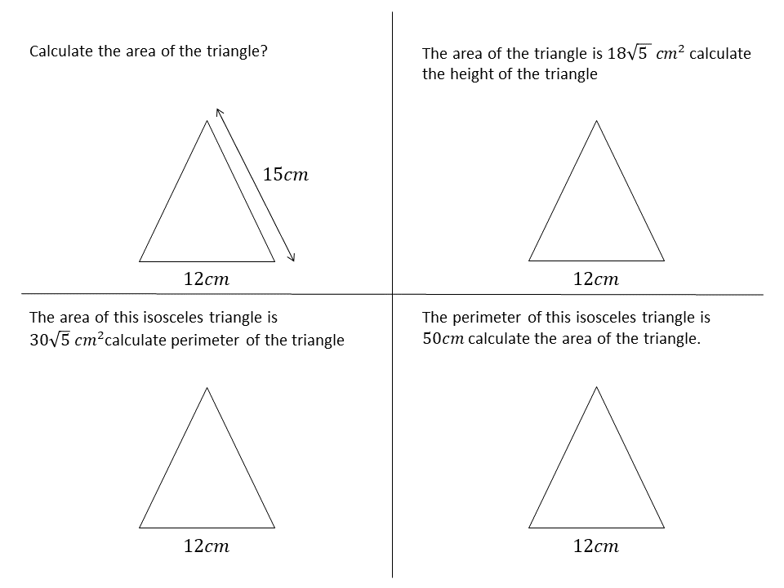  - Calculate the area of the triangle.  $$18\sqrt{21} {cm}^{2}$$ | - The area of the triangle is $18\sqrt{5}$ cm².  Calculate the height.  $$3\sqrt{5} cm$$
- The area of this triangle is $30\sqrt{5}$ cm². Calculate the perimeter.  $$12+2\sqrt{161} cm$$ | - The perimeter of the triangle is 50 cm. Calculate the area.  $$30\sqrt{13} {cm}^{2}$$
- Show that $\frac{\sqrt{18y}}{\sqrt{2y}}$ is an integer.

$$\frac{\sqrt{18}\sqrt{y}}{\sqrt{2}\sqrt{y}}=\sqrt{9}=3$$
- Simplify the following.
- $\sqrt{45}+\sqrt{80}-\sqrt{72}$  $$7\sqrt{5}-6\sqrt{2}$$ | - $3\sqrt{24}+6\sqrt{150}-5\sqrt{54}$  $$21\sqrt{6}$$
- $\frac{4+\sqrt{12}}{2}$  $$2+\sqrt{3}$$ | - $\frac{2\sqrt{6}×3\sqrt{7}}{12\sqrt{21}}$  $$\frac{\sqrt{2}}{2}$$

- Simplify the following.
- ${\left(3\sqrt{2}\right)}^{3}$  $$=3^{3}{\sqrt{2}}^{3}$$  $=27×2\sqrt{2}$  $=$  $$54\sqrt{2}$$ | - ${\left(5\sqrt{3}\right)}^{3}$  $$375\sqrt{3}$$ | - $2{\left(3\sqrt{3}\right)}^{3}$  $$162\sqrt{3}$$
- ${\left(\sqrt{5}\right)}^{4}$  $$25$$ | - ${\left(-\sqrt{3} \right)}^{4}$  $$9$$ | - ${\left(2\sqrt{2}\right)}^{5}$  $$128\sqrt{2}$$
- $-3{\left(2\sqrt{5}\right)}^{3}$  $$-120\sqrt{5}$$ | - $2{\left(-3\sqrt{2}\right)}^{3}$  $$-32\sqrt{2}$$ | - $5{\left(2\sqrt{3}\right)}^{4}$  $$720$$
- $\frac{{\left(2\sqrt{7}\right)}^{3}}{4}$  $$14\sqrt{7}$$ | - $\frac{{\left(3\sqrt{2}\right)}^{3}}{4}$  $$\frac{27\sqrt{2}}{2}$$ | - $\frac{{\left(3\sqrt{2}\right)}^{4}}{4}$  $$81$$
- $\frac{{\left(5\sqrt{2}\right)}^{2}}{4}$ $×$ $\frac{{\left(2\sqrt{3}\right)}^{3}}{3}$  $$100\sqrt{3}$$ | - $\frac{{\left(2\sqrt{3}\right)}^{2}}{9}$ $×$ $\frac{{\left(-3\sqrt{2}\right)}^{4}}{3}$  $$144$$ | - $\frac{{\left(2\sqrt{5}\right)}^{3}}{5}$ $×$ $\frac{{\left(-2\sqrt{3}\right)}^{5}}{24}$  $$-96\sqrt{15}$$
- $\frac{{\left(3\sqrt{3}\right)}^{3}}{2}$ $÷$ $\frac{{\left(5\sqrt{2}\right)}^{2}}{4}$  $$\frac{81\sqrt{3}}{25}$$ | - $\frac{{\left(2\sqrt{5}\right)}^{4}}{50}$ $÷$ $\frac{{\left(2\sqrt{3}\right)}^{3}}{5}$  $$\frac{5}{3\sqrt{3}}$$ | - $\frac{{\left(2\sqrt{2}\right)}^{3}}{9}$ $÷$ $\frac{{\left(2\sqrt{8}\right)}^{2}}{{\left(\sqrt{27}\right)}^{3}}$  $$\frac{9\sqrt{6}}{2}$$

Distributive Law with Surds

- Expanding Brackets with Surds
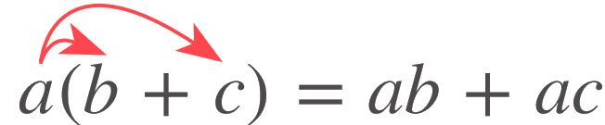

- Expand brackets.
- Simplify.

- Example Expand brackets with surds
$\sqrt{3}\left(3\sqrt{5}+\sqrt{6}\right)$  1. $3\sqrt{15}+\sqrt{18}$  2. $3\sqrt{15}+3\sqrt{2}$ | $3\sqrt{6}\left(2\sqrt{10}-4\sqrt{6}\right)$  1. $6\sqrt{60}-12\sqrt{36}$  2. $12\sqrt{15}-72$

- Guided Practice
Simplify:
- $\sqrt{2}\left(\sqrt{10}-\sqrt{2}\right)$  $$2\sqrt{5}-2$$ | - $\sqrt{6}\left(\sqrt{8}-2\right)$  $$4\sqrt{3}-2\sqrt{6}$$ | - $\sqrt{3}(\sqrt{2}+\sqrt{5})$  $$\sqrt{6}+\sqrt{15}$$
- $2\sqrt{3}\left(\sqrt{5}+\sqrt{7}\right)$  $$2\sqrt{15}+2\sqrt{21}$$ | - $3\sqrt{2}\left(2\sqrt{13}-\sqrt{11}\right)$  $$6\sqrt{26}-3\sqrt{22}$$ | - $4\sqrt{5}(\sqrt{5}-\sqrt{10})$  $$20-20\sqrt{2}$$

Foundation
- Use the distributive law to expand the following and simplify the surds where necessary.
- $\sqrt{2}(\sqrt{10}-\sqrt{2})$  $$2\sqrt{5}-2$$ | - $\sqrt{6}(3+\sqrt{3})$  $$3\sqrt{6}+3\sqrt{2}$$
- $\sqrt{5}(\sqrt{15}+4)$  $$5\sqrt{3}+4\sqrt{5}$$ | - $\sqrt{6}(\sqrt{8}-2)$  $$4\sqrt{3}-2\sqrt{6}$$
- $3\sqrt{3}(9-\sqrt{21})$  $$27\sqrt{3}-9\sqrt{7}$$ | - $3\sqrt{7}(\sqrt{14}-2\sqrt{7})$  $$21\sqrt{2}-42$$
- $-2\sqrt{6}(3\sqrt{2}-2\sqrt{3})$  $$-12\sqrt{3}+12\sqrt{2}$$ | - $3\sqrt{7}(2\sqrt{7}+3\sqrt{14})$  $$42+63\sqrt{2}$$
- $-2\sqrt{8}(2\sqrt{2}-3\sqrt{20})$  $$-16+24\sqrt{10}$$ | - $2\sqrt{3}(7\sqrt{6}+5\sqrt{3})$  $$42\sqrt{2}+30$$

- Expand and simplify the following.
- $\sqrt{2}\left(3-\sqrt{3}\right)-\sqrt{8}$  $$\sqrt{2}-\sqrt{6}$$ | - $\sqrt{8}\left(\sqrt{6}+\sqrt{2}\right)-\sqrt{3}$  $$3\sqrt{3}+4$$
- $\sqrt{5}\left(\sqrt{2}+1\right)-\sqrt{40}$  $$\sqrt{5}-\sqrt{10}$$ | - $\sqrt{44}-2\left(\sqrt{11}-1\right)$  $$2$$
- $\sqrt{24}-2\sqrt{2}\left(\sqrt{3}-4\right)$  $$8\sqrt{2}$$ | - $2\sqrt{3}\left(\sqrt{6}-\sqrt{3}\right)-\sqrt{50}$  $$\sqrt{2}-6$$

Expanding Binomials with Surds

- Expanding Brackets with Surds
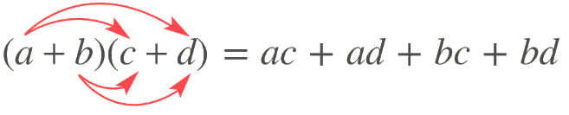

- Expand brackets.
- Simplify.

- Example Expand brackets with surds
$(\sqrt{15}+2)(\sqrt{3}-3)$  $$=\sqrt{45}-3\sqrt{15}+2\sqrt{3}-6$$  $=3\sqrt{5}-3\sqrt{15}+2\sqrt{3}-6$ | ${\left(\sqrt{15}-\sqrt{6}\right)}^{2}$  $=15-2\sqrt{90}+6$  $=21-2\sqrt{90}$  $=21-6\sqrt{10}$

- Guided Practice
Simplify:
- $\left(\sqrt{3}+1\right)\left(\sqrt{2}-1\right)$  $$\sqrt{6}-\sqrt{3}+\sqrt{2}-1$$ | - $\left(\sqrt{5}+1\right)\left(\sqrt{5}-1\right)$  $$4$$ | - ${\left(\sqrt{7}-\sqrt{5}\right)}^{2}$  $$12-2\sqrt{35}$$
- $\left(2\sqrt{6}-1\right)\left(\sqrt{6}-2\right)$  $$14-5\sqrt{6}$$ | - $\left(5\sqrt{2}-1\right)\left(3\sqrt{2}+3\right)$  $$27+12\sqrt{2}$$ | - ${\left(\sqrt{13}+\sqrt{9}\right)}^{2}$  $$22+6\sqrt{13}$$

Foundation
- Expand these binomial expressions.
- $\left(\sqrt{3}+1\right)\left(\sqrt{2}-1\right)$  $$\sqrt{6}+\sqrt{2}-\sqrt{3}-1$$ | - $\left(\sqrt{5}-2\right)\left(\sqrt{7}+3\right)$  $$\sqrt{35}+3\sqrt{5}-2\sqrt{7}-6$$ | - $\left(\sqrt{5}+\sqrt{2}\right)\left(\sqrt{3}+\sqrt{2}\right)$  $$\sqrt{15}+\sqrt{10}+\sqrt{6}+2$$
- $\left(\sqrt{6}-1\right)\left(\sqrt{6}-2\right)$  $$8-3\sqrt{6}$$ | - $\left(\sqrt{7}-2\right)\left(2\sqrt{7}+5\right)$  $$4+\sqrt{7}$$ | - $\left(3\sqrt{2}-1\right)\left(\sqrt{6}-\sqrt{3}\right)$  $$7\sqrt{3}-4\sqrt{6}$$

- Expand these expressions.
- $\left(3-2\sqrt{7}\right)\left(\sqrt{21}-4\sqrt{3}\right)$  $$11\sqrt{21}-26\sqrt{3}$$ | - $\left(2\sqrt{6}+5\right)\left(\sqrt{30}-2\sqrt{5}\right)$  $$2\sqrt{5}+\sqrt{30}$$ | - $\left(3\sqrt{5}+1\right)\left(\sqrt{7}+2\sqrt{35}\right)$  $$30+\sqrt{7}+5\sqrt{35}$$
- $\left(4\sqrt{2}+\sqrt{7}\right)\left(3\sqrt{14}-5\right)$  $$19\sqrt{7}+\sqrt{2}$$ | - $\left(3\sqrt{3}+4\right)\left(\sqrt{6}-2\sqrt{2}\right)$  $$\sqrt{2}-2\sqrt{6}$$ | - $\left(5-3\sqrt{2}\right)\left(2\sqrt{10}+3\sqrt{5}\right)$  $$\sqrt{10}+3\sqrt{5}$$

- Expand these expressions.
- $\left(\sqrt{5}+2\right)\left(\sqrt{5}+1\right)$  $$7+3\sqrt{5}$$ | - $\left(2+2\sqrt{5}\right)\left(1+\sqrt{5}\right)$  $$12+4\sqrt{5}$$ | - $\left(2\sqrt{7}+2\right)\left(3\sqrt{7}-6\right)$  $$30-6\sqrt{7}$$
- $\left(2+\sqrt{5}\right)\left(1+\sqrt{5}\right)$  $$7+3\sqrt{5}$$ | - $\left(\sqrt{5}+2\right)\left(\sqrt{5}-1\right)$  $$3+\sqrt{5}$$ | - $\left(\sqrt{7}+\sqrt{6}\right)\left(\sqrt{7}-\sqrt{6}\right)$  $$1$$
- $\left(2-\sqrt{5}\right)\left(1+\sqrt{5}\right)$  $$-3+\sqrt{5}$$ | - $\left(\sqrt{7}+2\right)\left(\sqrt{7}-1\right)$  $$5+\sqrt{7}$$ | - $\left(\sqrt{7}-\sqrt{6}\right)\left(\sqrt{7}-\sqrt{6}\right)$  $$13-2\sqrt{42}$$
- $\left(\sqrt{5}-2\right)\left(\sqrt{5}-1\right)$  $$7-3\sqrt{5}$$ | - $\left(2\sqrt{7}+2\right)\left(3\sqrt{7}-1\right)$  $$40+4\sqrt{7}$$ | - ${\left(\sqrt{7}+\sqrt{6}\right)}^{2}$  $$13+2\sqrt{2}$$

Development
- Expand these perfect squares.
$${\left(a+b\right)}^{2}=a^{2}+2ab+b^{2}$$
$${\left(a-b\right)}^{2}=a^{2}-2ab+b^{2}$$
- ${\left(\sqrt{3}+1\right)}^{2}$  $$4+2\sqrt{3}$$ | - ${\left(2-\sqrt{6}\right)}^{2}$  $$10-4\sqrt{6}$$ | - ${\left(4+\sqrt{7}\right)}^{2}$  $$23+8\sqrt{7}$$
- ${\left(2\sqrt{3}+4\right)}^{2}$  $$28+16\sqrt{3}$$ | - ${\left(2\sqrt{7}+\sqrt{5}\right)}^{2}$  $$33+4\sqrt{35}$$ | - ${\left(3\sqrt{2}-2\sqrt{3}\right)}^{2}$  $$30-12\sqrt{6}$$
- ${\left(5\sqrt{3}-2\sqrt{8}\right)}^{2}$  $$107-40\sqrt{6}$$ | - ${\left(3\sqrt{5}+4\sqrt{7}\right)}^{2}$  $$157+24\sqrt{35}$$ | - ${\left(5\sqrt{6}+3\sqrt{5}\right)}^{2}$  $$195+30\sqrt{30}$$

- Expand these using the difference of two squares.
$$(a+b)(a-b)=a^{2}-b^{2}$$
- $\left(3-\sqrt{2}\right)\left(3+\sqrt{2}\right)$  $$7$$ | - $\left(5-\sqrt{6}\right)\left(5+\sqrt{6}\right)$  $$19$$ |  | - $\left(\sqrt{3}+\sqrt{2}\right)\left(\sqrt{3}-\sqrt{2}\right)$  $$1$$
- $\left(3\sqrt{2}-\sqrt{11}\right)\left(3\sqrt{2}+\sqrt{11}\right)$  $$7$$ | - $\left(2\sqrt{6}+3\right)\left(2\sqrt{6}-3\right)$  $$15$$ |  | - $\left(7-2\sqrt{5}\right)\left(7+2\sqrt{5}\right)$  $$29$$
- $\left(5\sqrt{8}-10\sqrt{2}\right)\left(5\sqrt{8}+10\sqrt{2}\right)$  $$0$$ |  | - $\left(3\sqrt{7}-4\sqrt{6}\right)\left(3\sqrt{7}+4\sqrt{6}\right)$  $$-33$$
- $\left(2\sqrt{10}+4\sqrt{5}\right)\left(2\sqrt{10}-4\sqrt{5}\right)$  $$-40$$ |  | - $\left(4\sqrt{10}-5\sqrt{6}\right)\left(4\sqrt{10}+5\sqrt{6}\right)$  $$10$$

- What do you notice about the result of a difference of two squares above?

The answer has no surds.
- Simplify the following expressions.
- $5×5$  $$25$$ | - $\sqrt{5}×5\sqrt{5}$  $$25$$ | - $5\left(5+5\sqrt{5}\right)$  $$25+25\sqrt{5}$$ | - $\left(5+\sqrt{5}\right)\left(5-\sqrt{5}\right)$  $$20$$
- $5×\sqrt{5}$  $$5\sqrt{5}$$ | - $5\sqrt{5}×5\sqrt{5}$  $$125$$ | - $5\sqrt{5}\left(5+\sqrt{5}\right)$  $$25+25\sqrt{5}$$ | - $\left(5+\sqrt{5}\right)\left(5+5\sqrt{5}\right)$  $$50+30\sqrt{5}$$
- $\sqrt{5}×\sqrt{5}$  $$5$$ | - $5\left(5+\sqrt{5}\right)$  $$25+5\sqrt{5}$$ | - $5\sqrt{5}\left(\sqrt{5}+5\sqrt{5}\right)$  $$150$$ | - $\left(5+5\sqrt{5}\right)\left(5+5\sqrt{5}\right)$  $$150+50\sqrt{5}$$
- $5×5\sqrt{5}$  $$25\sqrt{5}$$ | - $\sqrt{5}\left(5+\sqrt{5}\right)$  $$5+5\sqrt{5}$$ | - $\left(5+\sqrt{5}\right)\left(5+\sqrt{5}\right)$  $$30+10\sqrt{5}$$ | - $\left(\sqrt{5}+5\sqrt{5}\right)\left(\sqrt{5}+\sqrt{5}\right)$  $$60$$

- Find the area of these shapes in exact form.
$$7+4\sqrt{3}$$ | 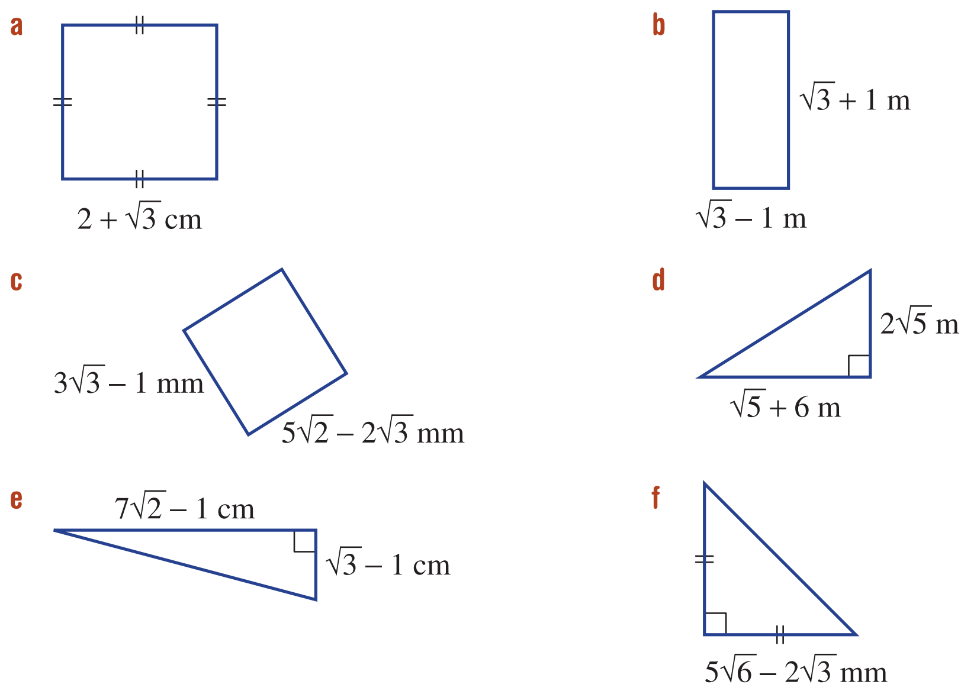  $$2$$
$$\frac{1}{2}\left(7\sqrt{6}-7\sqrt{2}-\sqrt{3}+1\right)$$ | $$81-30\sqrt{2}$$

- These rectangles are similar. The scale factor is 4.
Find the area of $B$ in its simplest form.
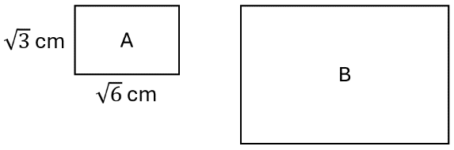

$48\sqrt{2}$ cm²

Mastery
- Simplify the following.
- ${\left(1+ \frac{1}{\sqrt{2}}\right)}^{2}$  $$\frac{3}{2}+\frac{2}{\sqrt{2}}$$ | - ${\left(\sqrt{3}-\frac{1}{\sqrt{3}}\right)}^{2}$  $$\frac{4}{3}$$

- Show that $x=-3+2\sqrt{2}$ satisfies the equation $x^{2}+6x+1=0$

$${LHS=\left(-3+2\sqrt{2}\right)}^{2}+6\left(-3+2\sqrt{2}\right)+1$$
$$=9-12\sqrt{2}+8-18+12\sqrt{2}+1$$
$$=0=RHS$$
- Find the value of $a$ and $b$.
- ${\left(\sqrt{3}+1\right)}^{2}=a+b\sqrt{3}$  $$a=4,b=2$$ | - ${\left(4-\sqrt{5}\right)}^{2}=a+b\sqrt{5}$  $$a=21,b=-8$$
- ${\left(2\sqrt{3}+\sqrt{2}\right)}^{2}=a+b\sqrt{6}$  $$a=14,b=4$$ | - ${\left(2\sqrt{2}+1\right)}^{2}=a+4\sqrt{b}$  $$a=9, b=2$$
- ${\left(2\sqrt{3}-3\sqrt{6}\right)}^{2}=a+b\sqrt{2}$  $$a=66, b=-12$$ | - ${\left(1-3\sqrt{2}\right)}^{2}-{\left(2+3\sqrt{2}\right)}^{2}=a+b\sqrt{2}$  $$a=-3, b=-18$$

Rationalising the Denominator

- Rationalising the Denominator
- Rationalising the denominator means to write a fraction with an integer denominator.
- Multiply the numerator and denominator by the surd in the denominator.
$$\frac{a}{\sqrt{b}}×\frac{\sqrt{b}}{\sqrt{b}}=\frac{a\sqrt{b}}{b}$$ | $$\frac{a}{b\sqrt{c}}×\frac{\sqrt{c}}{\sqrt{c}}=\frac{a\sqrt{c}}{bc}$$ | $$\frac{a\sqrt{b}}{c\sqrt{d}}×\frac{\sqrt{d}}{\sqrt{d}}=\frac{a\sqrt{bd}}{cd}$$

- Example Success Criteria
$$\frac{1}{\sqrt{2}} ×\frac{\sqrt{2}}{\sqrt{2}}$$  $$=\frac{\sqrt{2}}{2}$$ | $$\frac{2}{5\sqrt{3}}×\frac{\sqrt{3}}{\sqrt{3}}$$  $$=\frac{2\sqrt{3}}{15}$$

- Guided Practice
Rationalise these expressions.
- $\frac{1}{\sqrt{3}}$  $$\frac{\sqrt{3}}{3}$$ | - $\frac{\sqrt{2}}{\sqrt{3}}$  $$\frac{\sqrt{6}}{3}$$ | - $\frac{1+\sqrt{2}}{\sqrt{3}}$  $$\frac{\sqrt{3}+\sqrt{6}}{3}$$
- $\frac{\sqrt{6}-5}{\sqrt{2}}$  $$\frac{2\sqrt{3}-5\sqrt{2}}{2}$$ | - $\frac{\sqrt{3}}{2\sqrt{2}}$  $$\frac{\sqrt{6}}{4}$$ | - $\frac{8+3\sqrt{2}}{4\sqrt{5}}$  $$\frac{8\sqrt{5}+3\sqrt{10}}{20}$$

- Key Ideas
- Rationalising the denominator means to write the denominator as an …………………
- For $\frac{a\sqrt{b}}{c\sqrt{d}}$, we rationalise the denominator by multiplying ……………… and ……………… by …………

Foundation
- Write the missing number.
- $\sqrt{3}×$ …… = 3  $$\sqrt{3}$$ | - …… $× \sqrt{5}=5$  $$\sqrt{5}$$ | - $2\sqrt{5}×$ …… = 10  $$\sqrt{5}$$
- $4\sqrt{3}×$ …… = 12  $$\sqrt{3}$$ | - …… $× \sqrt{7}=21$  $$3\sqrt{7}$$ | - $3\sqrt{6}×$…… = 18  $$\sqrt{6}$$
- $\frac{1}{\sqrt{3}}×\frac{ }{ }=\frac{\sqrt{3}}{3}$  $$\frac{\sqrt{3}}{\sqrt{3}}$$ | - $\frac{1}{\sqrt{7}}×\frac{ }{ }=\frac{\sqrt{7}}{7}$  $$\frac{\sqrt{7}}{\sqrt{7}}$$ | - $\frac{2}{\sqrt{13}}×\frac{ }{ }=\frac{2\sqrt{13}}{13}$  $$\frac{\sqrt{13}}{\sqrt{13}}$$

- Rationalise these denominators.
- $\frac{1}{\sqrt{2}}$  $$\frac{\sqrt{2}}{2}$$ | - $\frac{1}{\sqrt{7}}$  $$\frac{\sqrt{7}}{7}$$ | - $\frac{3}{\sqrt{11}}$  $$\frac{3\sqrt{11}}{11}$$
- $\frac{4}{\sqrt{5}}$  $$\frac{4\sqrt{5}}{\sqrt{5}}$$ | - $\frac{\sqrt{5}}{\sqrt{3}}$  $$\frac{\sqrt{15}}{3}$$ | - $\frac{\sqrt{2}}{\sqrt{7}}$  $$\frac{\sqrt{14}}{7}$$

- Rewrite the following in the form $\frac{\sqrt{a}}{\sqrt{b}}$ and then rationalise the denominators.
- $\sqrt{\frac{2}{3}}$  $$\frac{\sqrt{6}}{3}$$ | - $\sqrt{\frac{5}{7}}$  $$\frac{\sqrt{35}}{7}$$ | - $\sqrt{\frac{2}{5}}$  $$\frac{\sqrt{10}}{5}$$
- $\sqrt{\frac{7}{3}}$  $$\frac{\sqrt{21}}{3}$$ | - $\sqrt{\frac{6}{7}}$  $$\frac{\sqrt{42}}{7}$$ | - $\sqrt{\frac{17}{2}}$  $$\frac{\sqrt{34}}{2}$$

- Rationalise these denominators.
- $\frac{4\sqrt{2}}{\sqrt{7}}$  $$\frac{4\sqrt{14}}{7}$$ | - $\frac{5\sqrt{2}}{\sqrt{3}}$  $$\frac{5\sqrt{6}}{3}$$ | - $\frac{3\sqrt{5}}{\sqrt{2}}$  $$\frac{3\sqrt{10}}{2}$$
- $\frac{3\sqrt{6}}{\sqrt{7}}$  $$\frac{3\sqrt{42}}{7}$$ | - $\frac{7\sqrt{3}}{\sqrt{10}}$  $$\frac{7\sqrt{30}}{10}$$ | - $\frac{2\sqrt{7}}{\sqrt{15}}$  $$\frac{2\sqrt{105}}{15}$$

- By rationalising the denominator, show that $\frac{n}{\sqrt{n}}$ $=\sqrt{n}$.
$$\frac{n\sqrt{n}}{n}=\sqrt{n}$$
Therefore, simplify:
- $\frac{2}{\sqrt{2}}$  $$\sqrt{2}$$ | - $\frac{5}{\sqrt{5}}$  $$\sqrt{5}$$ | - $\frac{93}{\sqrt{93}}$  $$\sqrt{93}$$ | - $\frac{ab}{\sqrt{ab}}$  $$\sqrt{ab}$$

Development
- Rationalise these denominators.
- $\frac{5}{\sqrt{2}}$  $$\frac{5\sqrt{2}}{2}$$ | - $\frac{5}{\sqrt{6}}$  $$\frac{5\sqrt{6}}{6}$$ | - $\frac{5}{\sqrt{5}}$  $$\sqrt{5}$$
- $\frac{6}{\sqrt{2}}$  $$3\sqrt{2}$$ | - $\frac{5}{2\sqrt{6}}$  $$\frac{5\sqrt{6}}{12}$$ | - $\frac{8}{\sqrt{8}}$  $$\sqrt{8}$$
- $\frac{6}{\sqrt{3}}$  $$2\sqrt{3}$$ | - $\frac{5}{3\sqrt{6}}$  $$\frac{5\sqrt{6}}{18}$$ | - $\frac{10}{\sqrt{8}}$  $$\frac{5\sqrt{8}}{4}$$
- $\frac{4}{\sqrt{3}}$  $$\frac{4\sqrt{3}}{3}$$ | - $\frac{5}{10\sqrt{6}}$  $$\frac{\sqrt{6}}{12}$$ | - $\frac{10}{\sqrt{12}}$  $$\frac{5\sqrt{12}}{6}$$
- $\frac{4}{\sqrt{6}}$  $$\frac{2\sqrt{6}}{3}$$ | - $\frac{5}{10\sqrt{5}}$  $$\frac{\sqrt{5}}{10}$$ | - $\frac{10}{2\sqrt{3}}$  $$\frac{5\sqrt{3}}{3}$$

- Rationalise these denominators.
- $\frac{4\sqrt{7}}{5\sqrt{3}}$  $$\frac{4\sqrt{21}}{15}$$ | - $\frac{2\sqrt{3}}{3\sqrt{2}}$  $$\frac{\sqrt{6}}{3}$$ | - $\frac{5\sqrt{7}}{3\sqrt{5}}$  $$\frac{\sqrt{35}}{3}$$
- $\frac{5\sqrt{12}}{3\sqrt{27}}$  $$\frac{10}{9}$$ | - $\frac{9\sqrt{6}}{2\sqrt{3}}$  $$\frac{9\sqrt{2}}{2}$$ | - $\frac{7\sqrt{90}}{2\sqrt{70}}$  $$\frac{3\sqrt{7}}{2}$$

Mastery
- Determine the exact value of the area of the following shapes.
Express your answers using a rational denominator.
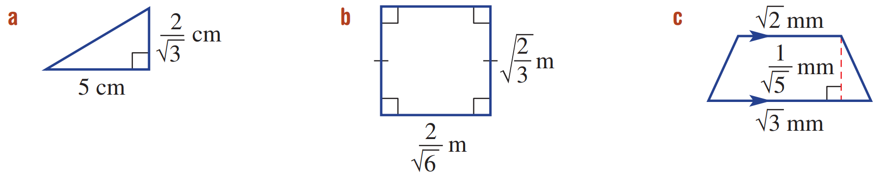  $$\frac{5\sqrt{3}}{3}$$ | $$\frac{2}{3}$$ | $$\frac{\sqrt{10}+\sqrt{15}}{10}$$

- Rationalise these denominators.
- $\frac{1+\sqrt{2}}{\sqrt{3}}$  $$\frac{\sqrt{3}+\sqrt{6}}{3}$$ | - $\frac{2-\sqrt{3}}{\sqrt{5}}$  $$\frac{2\sqrt{5}-\sqrt{15}}{5}$$ | - $\frac{\sqrt{5}+\sqrt{2}}{\sqrt{7}}$  $$\frac{\sqrt{35}+\sqrt{14}}{7}$$
- $\frac{\sqrt{2}+\sqrt{7}}{\sqrt{6}}$  $$\frac{2\sqrt{3}+\sqrt{42}}{6}$$ | - $\frac{6-\sqrt{10}}{\sqrt{5}}$  $$\frac{6\sqrt{5}-5\sqrt{2}}{5}$$ | - $\frac{3\sqrt{5}+5\sqrt{2}}{\sqrt{10}}$  $$\frac{3\sqrt{2}+2\sqrt{5}}{2}$$

- Simplify the following.
$$xy{\left(\frac{\sqrt{x}}{\sqrt{y}}-\frac{\sqrt{y}}{\sqrt{x}}\right)}^{2}$$

$${\left(x-y\right)}^{2}$$

Rationalising Binomial Denominators

- The Conjugate
The conjugate of $a+b\sqrt{c}$ is $a-b\sqrt{c}$.

- Identify the conjugate
Expression | Conjugate
$$7+\sqrt{3}$$
$$8+\sqrt{5}$$
$$\sqrt{5}+8$$
$$\sqrt{5}-8$$
$$4-\sqrt{7}$$
$$5+3\sqrt{2}$$
$$6-2\sqrt{3}$$
$$4\sqrt{6}-3$$

- The Conjugate Product
- The product of an expression and its conjugate is a difference of two squares.
- A conjugate product has no surds.
$\left(a+\sqrt{c}\right)\left(a-\sqrt{c}\right)$  $=a^{2}-c$ | $\left(a+b\sqrt{c}\right)\left(a-b\sqrt{c}\right)$  $=a^{2}-b^{2}c$

- Identify the conjugate product
- $\left(2+\sqrt{3}\right)\left(2-\sqrt{3}\right)$  $=2^{2}-{\left(\sqrt{3}\right)}^{2}$  $=4-3$  $=1$ | - $\left(5-\sqrt{6}\right)\left(5+\sqrt{6}\right)$  19 | - $\left(7-\sqrt{3}\right)\left(7+\sqrt{3}\right)$  46
- $\left(5+3\sqrt{6}\right)\left(5-3\sqrt{6}\right)$  $$-29$$ | - $\left(7+2\sqrt{5}\right)\left(7-2\sqrt{5}\right)$  29 | - $\left(12-2\sqrt{3}\right)\left(12+\sqrt{3}\right)$  132
- Rationalising Binomial Denominator
For binomial denominators, rationalise by multiplying by the conjugate.
$$\frac{a}{\sqrt{b}+\sqrt{c}}×\frac{\sqrt{b}-\sqrt{c}}{\sqrt{b}-\sqrt{c}}=\frac{a\sqrt{b}-a\sqrt{c}}{b^{2}-c^{2}}$$

$$\frac{a}{\sqrt{b}-\sqrt{c}}×\frac{\sqrt{b}+\sqrt{c}}{\sqrt{b}+\sqrt{c}}=\frac{a\sqrt{b}+a\sqrt{c}}{b^{2}-c^{2}}$$

- Example Rationalise a binomial denominator
$$\frac{3}{5+\sqrt{3}}×\frac{5-\sqrt{3}}{5-\sqrt{3}}$$  $$=\frac{15-3\sqrt{3}}{25-3}$$  $$=\frac{15-3\sqrt{3}}{22}$$ | $$\frac{\sqrt{5}}{2\sqrt{2}-3}×\frac{2\sqrt{2}+3}{2\sqrt{2}+3}$$  $$=\frac{2\sqrt{10}+3\sqrt{5}}{4×2-9}$$  $$=-\left(2\sqrt{10}+3\sqrt{5}\right)$$

- Guided Practice
Rationalise these expressions.
- $\frac{1}{\sqrt{3}-1}$ $×$ $\frac{\sqrt{3}+1}{\sqrt{3}+1}$  $$\frac{\sqrt{3}+1}{2}$$ | - $\frac{1}{\sqrt{5}-\sqrt{2}}$  $$\frac{\sqrt{5}+\sqrt{2}}{3}$$ | - $\frac{4}{\sqrt{3}+\sqrt{2}}$  $$4\sqrt{3}-4\sqrt{2}$$
- $\frac{\sqrt{3}-4}{\sqrt{3}+4}$  $$\frac{-19+8\sqrt{3}}{13}$$ | - $\frac{2\sqrt{7}}{2\sqrt{7}-5}$  $$\frac{28+10\sqrt{7}}{3}$$ | - $\frac{2\sqrt{3}}{\sqrt{5}+2\sqrt{6}}$  $$\frac{-2\sqrt{15}+12\sqrt{2}}{19}$$

- Key Ideas
- To rationalise expressions with binomial denominators, we multiply by the …………………
- The conjugate of $a+b$ is ……………, and the conjugate of $a-b$ is ……………

Foundation
- Expand these products of conjugate pairs.
- $\left(4-\sqrt{3}\right)\left(4+\sqrt{3}\right)$  $$13$$ | - $\left(5+\sqrt{7}\right)\left(5-\sqrt{7}\right)$  18
- $\left(\sqrt{6}-2\sqrt{10}\right)\left(\sqrt{6}+2\sqrt{10}\right)$  $$-34$$ | - $\left(a+\sqrt{b}\right)\left(a-\sqrt{b}\right)$  $$a^{2}-b$$

Do you get a rational number as a result in each example?
yes
- Why is $\frac{2}{4+\sqrt{3}}$ the same value as $\frac{2}{4+\sqrt{3}}×$ $\frac{4-\sqrt{3}}{4-\sqrt{3}}$?

You multiply the numerator and denominator by the same expression, so the resulting expression is equivalent.
Rationalise these denominators.
- $\frac{2}{4+\sqrt{3}}$  $$\frac{8-2\sqrt{3}}{13}$$ | - $\frac{1}{5-\sqrt{7}}$  $$\frac{5+\sqrt{7}}{9}$$ | - $\frac{\sqrt{5}}{8-\sqrt{5}}$  $$\frac{8\sqrt{5}+5}{59}$$
- $\frac{5}{\sqrt{6}-1}$  $$\sqrt{6}+1$$ | - $\frac{6}{\sqrt{2}+\sqrt{11}}$  $$\frac{2\sqrt{11}-2\sqrt{2}}{3}$$ | - $\frac{2+\sqrt{3}}{2-\sqrt{3}}$  $$7+4\sqrt{3}$$

- The expression $\frac{\sqrt{6}+1}{\sqrt{3}+\sqrt{2}}$ can be written as $a\sqrt{3}+b\sqrt{2}$. Find $a$ and $b$.

$$a=-1, b=2$$

Development
- Rationalise these denominators.
- $\frac{2}{\sqrt{2}+3}$  $$\frac{6-2\sqrt{2}}{7}$$ | - $\frac{7}{\sqrt{7}-3}$  $$\frac{-7\sqrt{7}-21 }{2}$$ | - $\frac{4\sqrt{5}}{5-\sqrt{3}}$  $$\frac{10\sqrt{5}+2\sqrt{15} }{11}$$
- $\frac{2}{3+\sqrt{2}}$  $$\frac{6-2\sqrt{2}}{7}$$ | - $\frac{\sqrt{7}}{\sqrt{7}-3}$  $$\frac{-7-3\sqrt{7}}{2}$$ | - $\frac{4\sqrt{5}}{5-2\sqrt{3}}$  $$\frac{20\sqrt{5}+8\sqrt{15}}{13}$$
- $\frac{2}{3-\sqrt{2}}$  $$\frac{6+2\sqrt{2}}{7}$$ | - $\frac{\sqrt{5}}{\sqrt{5}-3}$  $$\frac{-5-3\sqrt{5}}{4}$$ | - $\frac{4\sqrt{5}}{5-3\sqrt{3}}$  $$-10\sqrt{5}-6\sqrt{15}$$
- $\frac{7}{3-\sqrt{2}}$  $$3+\sqrt{2}$$ | - $\frac{\sqrt{5}}{5-\sqrt{3}}$  $$\frac{5\sqrt{5}+\sqrt{15}}{22}$$ | - $\frac{4\sqrt{3}}{5-3\sqrt{3}}$  $$-10\sqrt{3}-18$$
- $\frac{7}{\sqrt{2}-3}$  $$-\sqrt{2}-3$$ | - $\frac{2\sqrt{5}}{5-\sqrt{3}}$  $$\frac{5\sqrt{5}+\sqrt{15}}{11}$$ | - $\frac{4\sqrt{3}-\sqrt{2}}{5-3\sqrt{3}}$  $$\frac{-20\sqrt{3}-36+5\sqrt{2}+3\sqrt{6}}{2}$$

- Simplify by forming the lowest common denominator:
- $\frac{1}{\sqrt{3}+1}+\frac{1}{\sqrt{3}-1}$  $$\sqrt{3}$$ | - $\frac{3}{2\sqrt{5}-\sqrt{7}}-\frac{3}{2\sqrt{5}+\sqrt{7}}$  $$\frac{6\sqrt{7}}{13}$$

Mastery
- Show that the following expression is rational:
$$\frac{4}{2+\sqrt{5}}-\frac{1}{9-4\sqrt{5}}$$

$$=\frac{4}{2+\sqrt{5}} \frac{×(2-\sqrt{5})}{×(2-\sqrt{5})}-\frac{1}{9-4\sqrt{5}} \frac{×(9+4\sqrt{5})}{×(9+4\sqrt{5})}$$
$$=\frac{8-4\sqrt{5}}{-1}-\frac{9+4\sqrt{5}}{81-80}$$
$$=-17$$
- Simplify the following by rationalising the denominator.
- $\frac{5+\sqrt{2}}{5-\sqrt{2}}$  $$\frac{27+10\sqrt{2}}{23}$$ | - $\frac{1}{\sqrt{3}+1}+\frac{\sqrt{3}-1}{4}$  $$\frac{3\sqrt{3}-3}{4}$$ | - $\frac{42}{\sqrt{63}}-\frac{6}{\sqrt{7}+2}$  $$4$$

- Simplify the following by rationalising the denominator.
- $\frac{a\sqrt{b}}{c\sqrt{d}}$  $$\frac{a\sqrt{bd}}{cd}$$ | - $\frac{1}{a+\sqrt{b}}$  $$\frac{a-\sqrt{b}}{a^{2}-b}$$ | - $\frac{1}{\sqrt{a}}-\frac{1}{\sqrt{b}}$  $$\frac{\sqrt{a}}{a}-\frac{\sqrt{b}}{b}=\frac{b\sqrt{a}-a\sqrt{b}}{ab}$$
- $\frac{1}{a\sqrt{b}-c}$  $$\frac{a\sqrt{b}+c}{a^{2}b-c^{2}}$$ | - $\frac{1}{a\sqrt{b}+c\sqrt{d}}$  $$\frac{a\sqrt{b}-c\sqrt{d}}{a^{2}b-c^{2}d }$$

- Show these expressions are rational by rationalising the denominator.
- $\frac{1}{3+\sqrt{6}}+\frac{2}{\sqrt{6}}$  $$1$$ | - $\frac{4}{2+\sqrt{2}}+\frac{1}{3-2\sqrt{2}}$  $$7$$ | - $\frac{8}{3-\sqrt{7}}-\frac{6}{2\sqrt{7}-5}$  $$2$$

  - Rationalise the denominator of
$$\frac{1}{\sqrt{n}+\sqrt{n+1}}$$

$$\sqrt{n+1}-\sqrt{n}$$
  - Hence simplify
$$\frac{1}{1+\sqrt{2}}+\frac{1}{\sqrt{2}+\sqrt{3}}+\frac{1}{\sqrt{3}+\sqrt{4}}…+\frac{1}{\sqrt{99}+\sqrt{100}}$$

$$=\left(\sqrt{2}-1\right)+\left(\sqrt{3}-\sqrt{2}\right)+\left(\sqrt{4}-\sqrt{3}\right)+…\left(\sqrt{100}-\sqrt{99}\right)$$
$$=-1+\sqrt{100}=9$$

  - Expand ${\left(x+\frac{1}{x}\right)}^{2}$
$$x^{2}+2+\frac{1}{x^{2}}$$
  - Suppose that $x=\sqrt{7}+\sqrt{6}$
    - Show that $x+\frac{1}{x}=2\sqrt{7}$
$$\sqrt{7}+\sqrt{6}+\frac{1}{\sqrt{7}+\sqrt{6}}$$
$$=\sqrt{7}+\sqrt{6}+\frac{\sqrt{7}-\sqrt{6}}{1}$$
$$=2\sqrt{7}$$
    - Use the result in part a to find the value of $x^{2}+\frac{1}{x^{2}}$
$${\left(x+\frac{1}{x}\right)}^{2}=x^{2}+2+\frac{1}{x^{2}}$$
$$∴x^{2}+\frac{1}{x^{2}}={\left(x+\frac{1}{x}\right)}^{2}-2$$
$$={\left(2\sqrt{7}\right)}^{2}-2$$
$$=26$$

- Find the value of $\sqrt{7-4\sqrt{3}}×\sqrt{7+4\sqrt{3}}$

$$=\sqrt{\left(7-4\sqrt{3}\right)\left(7+4\sqrt{3}\right)}$$
$$=\sqrt{49-48}$$
$$=1$$

  - Write down the expansion of ${\left(a-b\right)}^{2}$
$$a^{2}-2ab+b^{2}$$
  - Use the expansion in part a to square $\sqrt{6+\sqrt{11}}-\sqrt{6-\sqrt{11}}$.

Let $a=\sqrt{6+\sqrt{11}}, b=\sqrt{6-\sqrt{11}}$
$${\left(a-b\right)}^{2}=\left(6+\sqrt{11}\right)-2\sqrt{6+\sqrt{11}}\sqrt{6-\sqrt{11}}+\left(6-\sqrt{11}\right)$$
$$=12-2\sqrt{\left(6+\sqrt{11}\right)\left(6-\sqrt{11}\right)}$$
$$=12-2\sqrt{36-11}$$
$$=12-2\sqrt{25}$$
$$=2$$
  - Hence evaluate $\sqrt{6+\sqrt{11}}-\sqrt{6-\sqrt{11}}$
$$\sqrt{2}$$

- If $x=\sqrt{1+\sqrt{1+\sqrt{1+\sqrt{1}…}}}$, find the value of $x$.

Notice that since this repeats infinitely, we can write as $x=\sqrt{1+x}$
Square both sides
$$x^{2}=1+x$$
Solve using quadratic formula
$$x=\frac{1±\sqrt{5}}{2}$$
$x$ must be positive as it is a root, so
$$x=\frac{1+\sqrt{5}}{2}$$
(this number $ϕ≈1.618$ is the golden ratio)

- If $\sqrt{x+\sqrt{x^{2}-4}}+\sqrt{x-\sqrt{x^{2}-4 }}=4$, find the value of $x$.
Let $a=\sqrt{x+\sqrt{x^{2}-4}}$, $b=\sqrt{x-\sqrt{x^{2}-4}}$
It is given that $a+b=4$

$$ab=\sqrt{\left(x+\sqrt{x^{2}-4}\right)\left(x-\sqrt{x^{2}-4}\right)}$$
$$=\sqrt{x^{2}-\left(x^{2}-4\right)}$$
$$=\sqrt{4}=2$$

$$a+b=4$$
$$ab=2$$
Solving simultaneously,
$$a\left(4-a\right)=2$$
$$a^{2}-4a+2=0$$
$a=2-\sqrt{2}$ or $2+\sqrt{2}$
You can similarly find values of $b$:
$b=2+\sqrt{2}$ or $2-\sqrt{2}$

Using values of $a:$
$$\sqrt{x+\sqrt{x^{2}-4 }}=2+\sqrt{2}$$
$$x+\sqrt{x^{2}-4}=6+4\sqrt{2}$$
$$x+\sqrt{x^{2}-4}=6+\sqrt{32}$$
By equating coefficients, $x=6$

$$\sqrt{x+\sqrt{x^{2}-4 }}=2-\sqrt{2}$$
$$x+\sqrt{x^{2}-4}=6-4\sqrt{2}$$
$$x+\sqrt{x^{2}-4}=6-\sqrt{32}$$
No solution.

You can repeat for values of $b$, the only solutions is again $x=6$

Therefore, $x=6$

